**Canvas Basics**

By Adolf Schmuck

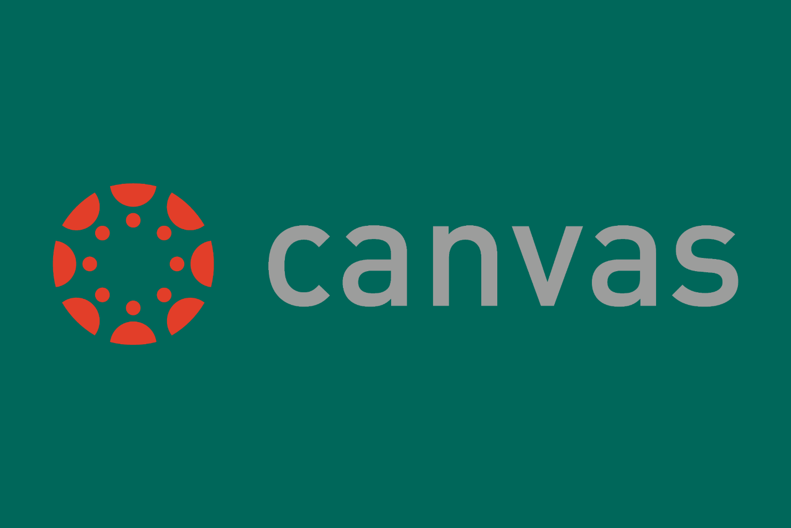

**Table of Contents**

Basic Navigation, Page 3

Creating a Module, Page 9

Creating Pages, Page 14

# **Basic Navigation**

After logging in to Canvas, the first thing you will see is the dashboard. The dashboard contains a list of your published courses, as well as a list of your unpublished courses, if you have any.

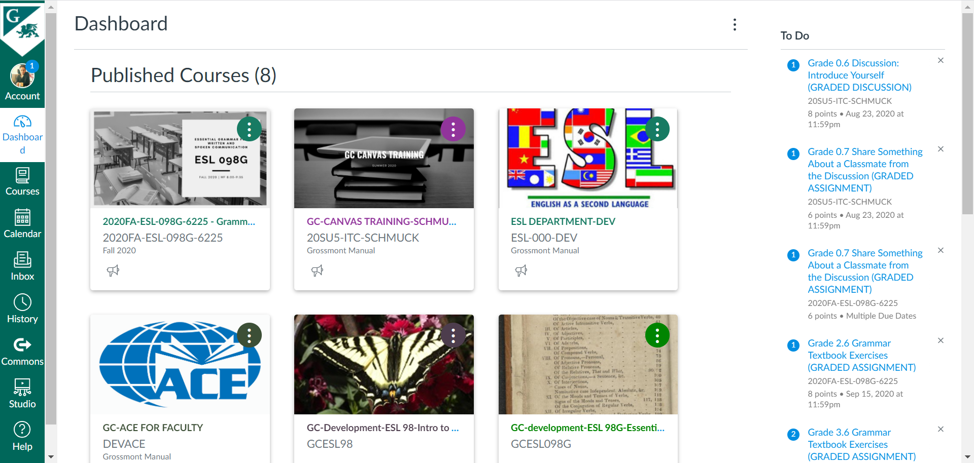

The sidebar on the left gives you different options: **Account, Dashboard, Courses, Calendar, Inbox, History, Commons, Studio,** and **Help.**

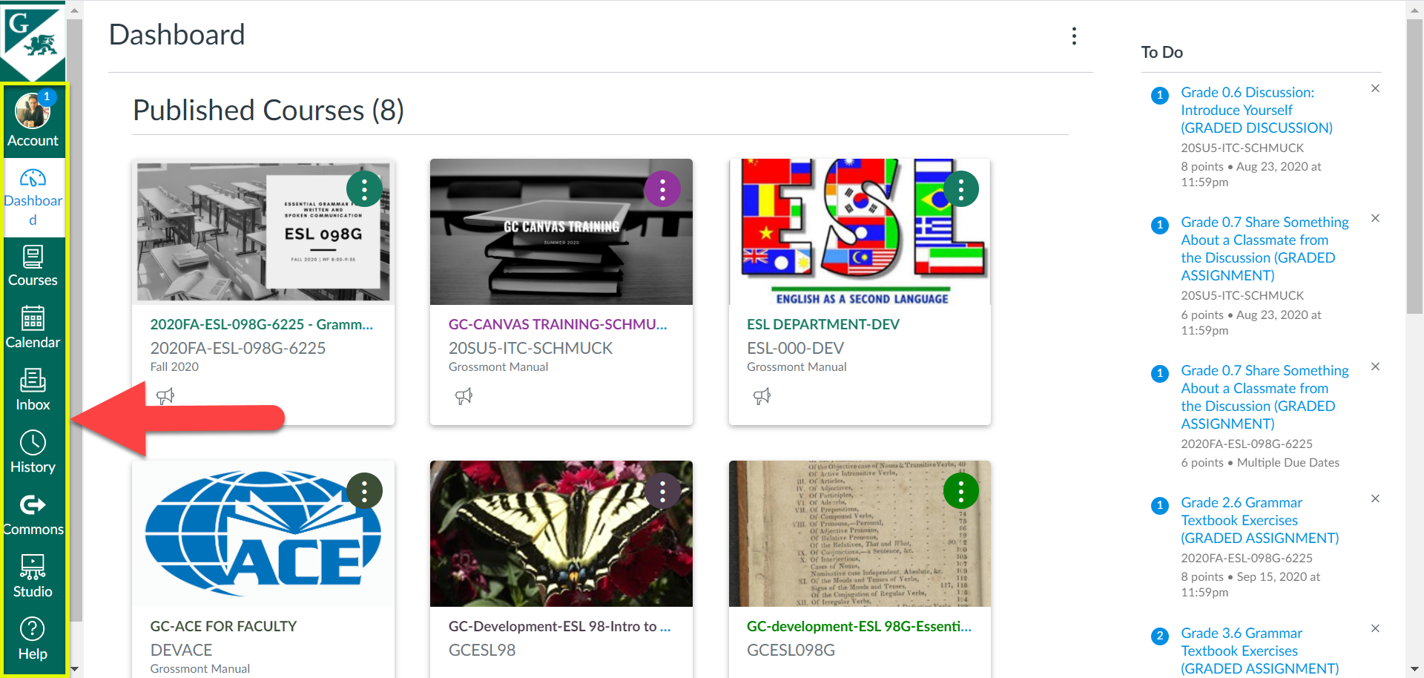

**Account** allows you to change your settings to your account. Here, you can set your account notification settings, edit your profile, upload files to use in your courses, create an ePortfolio, and more.

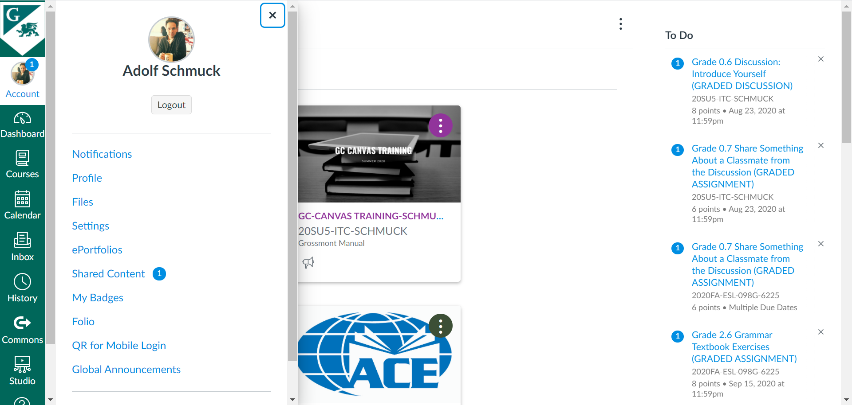

As noted above, **Dashboard** shows a list of courses you are enrolled in, either as the main facilitator of the course, or as an observer.



**Courses** also shows a list of your courses, though as a list instead of on the dashboard. If you scroll to the bottom, you can customize your list of courses by clicking on the “All Courses” link. This allows you to choose the courses that you want to display.

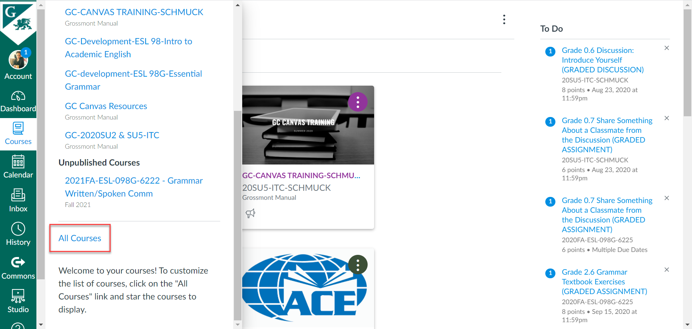

**Calendar** allows you to use the Calendar to keep track of important events and assignments. The Canvas Calendar collects information from all of your Canvas courses in one place. Here, you will be able to see any events for your courses that you have added to the calendar. On the right side, you can choose which calendars you want displayed by clicking on the box next to the course.

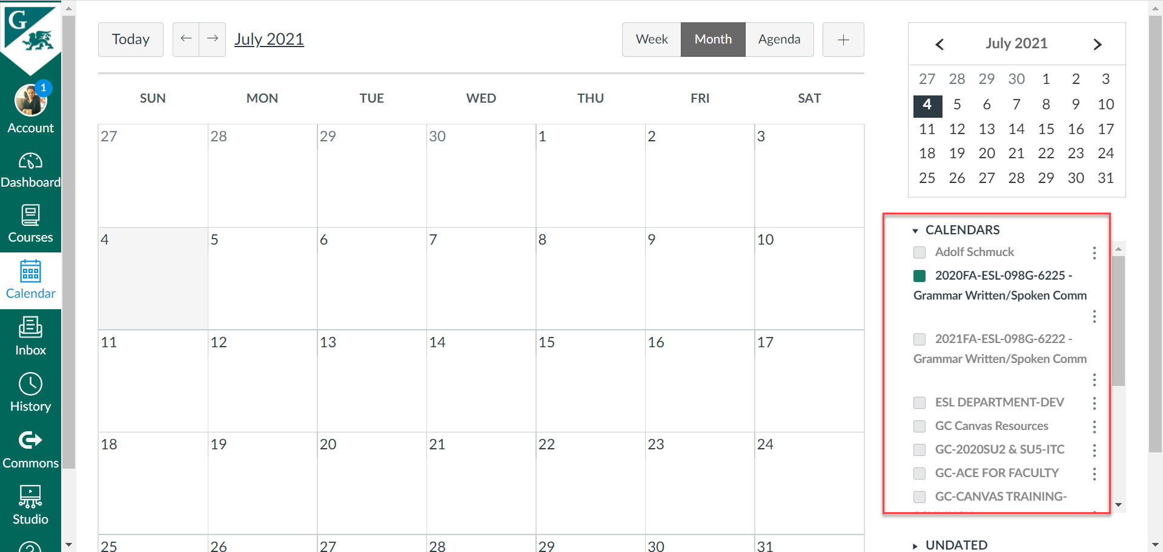

**Inbox** allows Canvas users to send and receive messages. The messages appear on the left side.

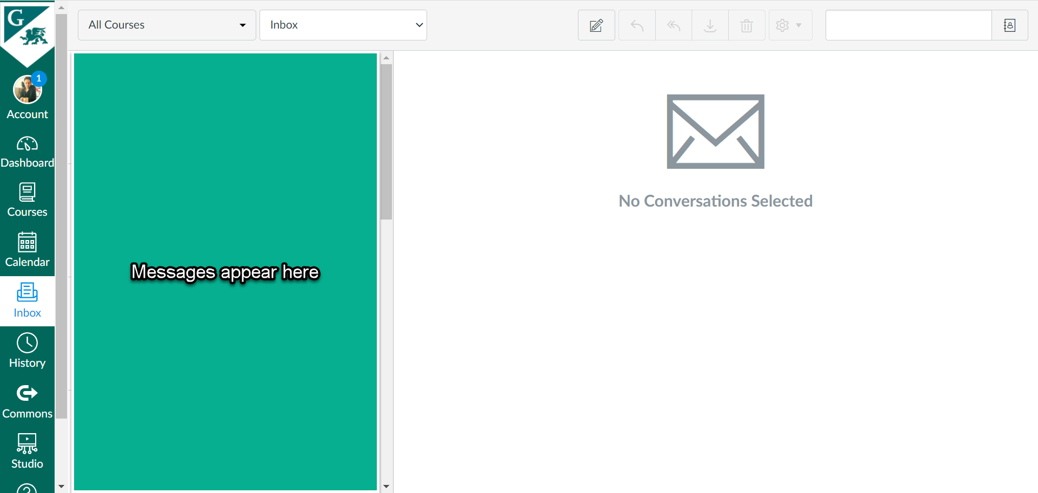

**History** gives you your recent Canvas activity history. Clicking on an item in the history view will take you to that item.

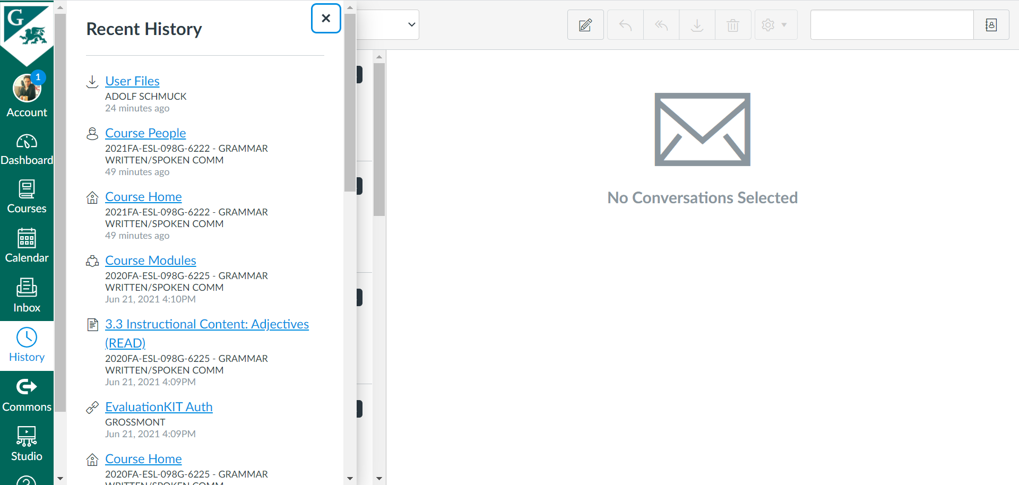

**Commons** allows you to upload or download layouts, assignments, and quizzes that have already been made on Canvas.

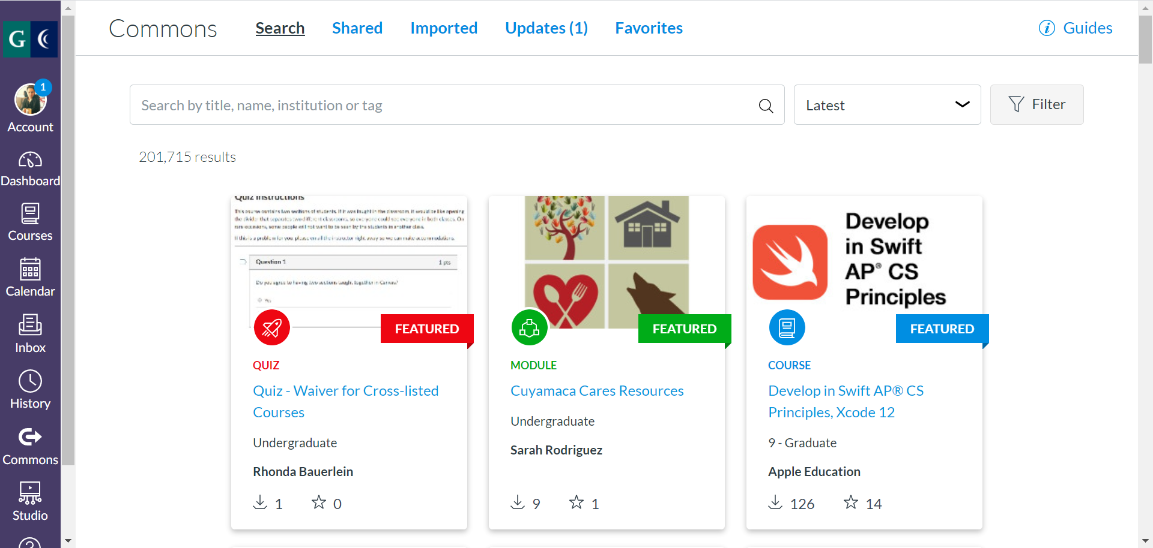

**Studio** is a media tool that allows students and instructors to upload, create, edit, manage, share and discuss audio and video files. As instructors, you can record your own videos, either through screen capture or webcam capture. You can also upload your own media files to use in your courses, as well as add videos from YouTube.

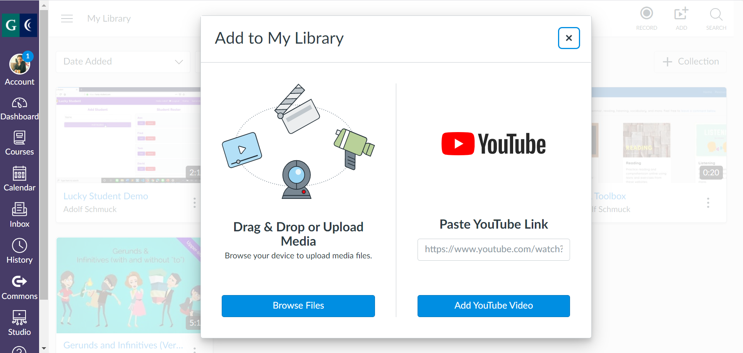

**Help** gives you access to the Canvas guides in order to find answers to common questions. You can also contact Canvas support, as your instructor a question (for students), call for help, and more.

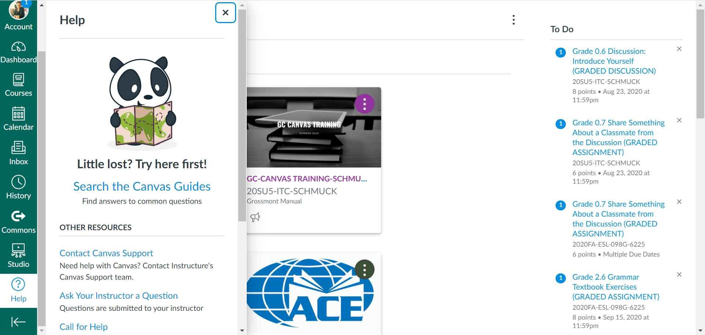

# **Creating a Module**

In this section, you will learn how to create a module for your course. The creation and organization of modules is up to the course and instructor. In this example, we have a module containing eight pages (0.1, 0.2, 0.3, etc.).

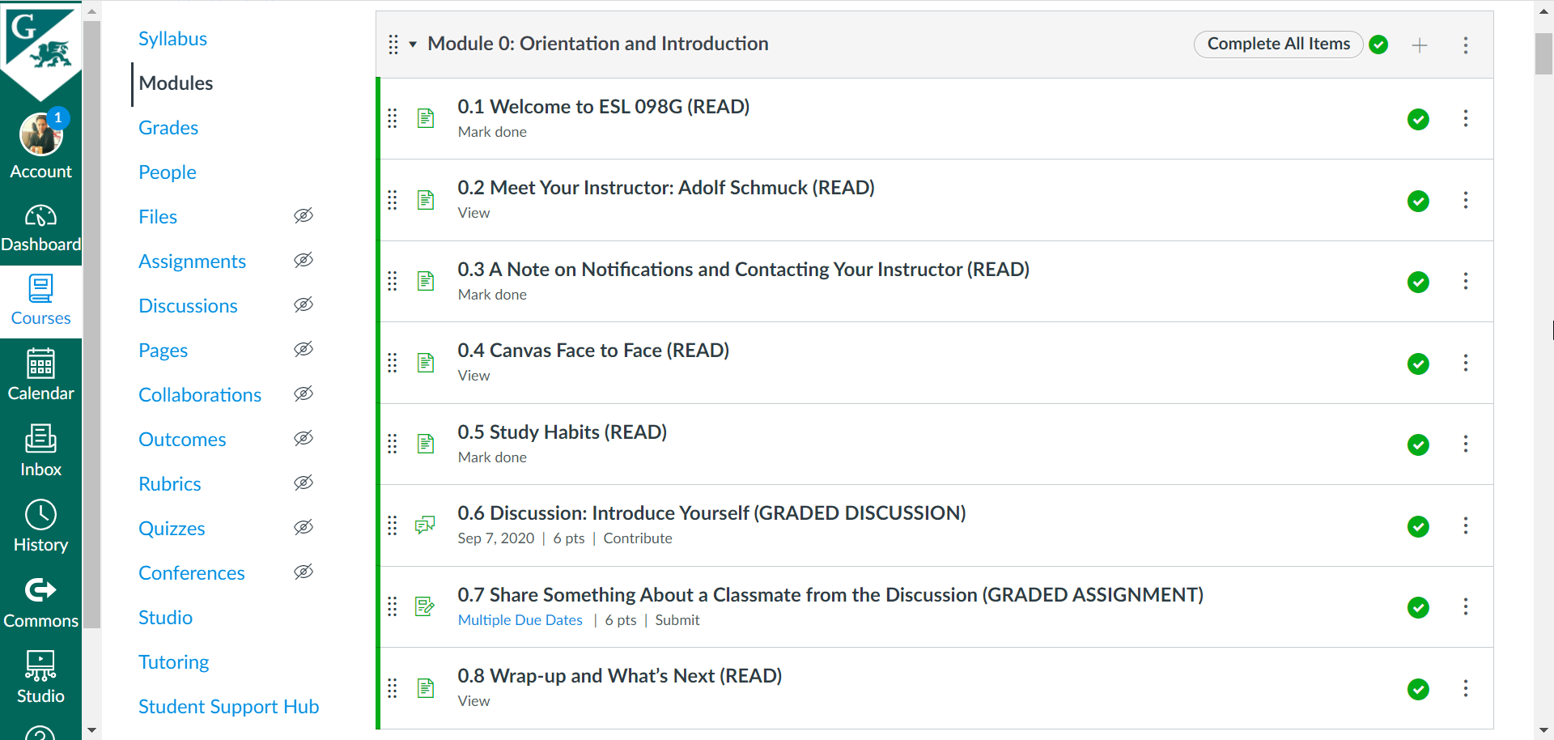

1. To begin, choose the course you would like to create a module for in the Dashboard. Notice that in this example, the course is unpublished.

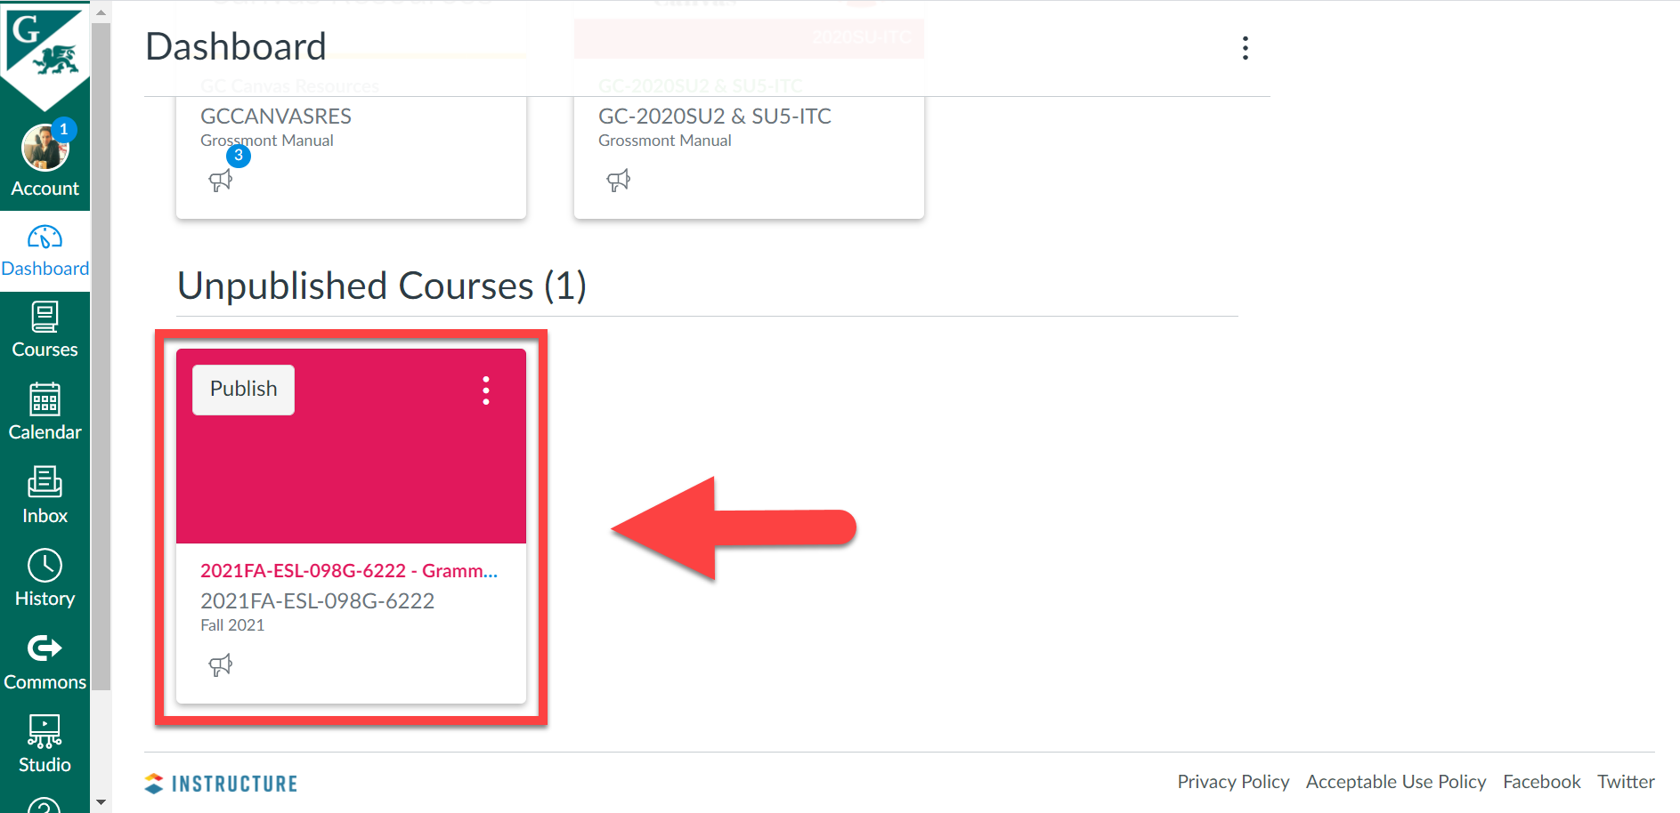

1. Go to **Modules** on the left to create a new Module.

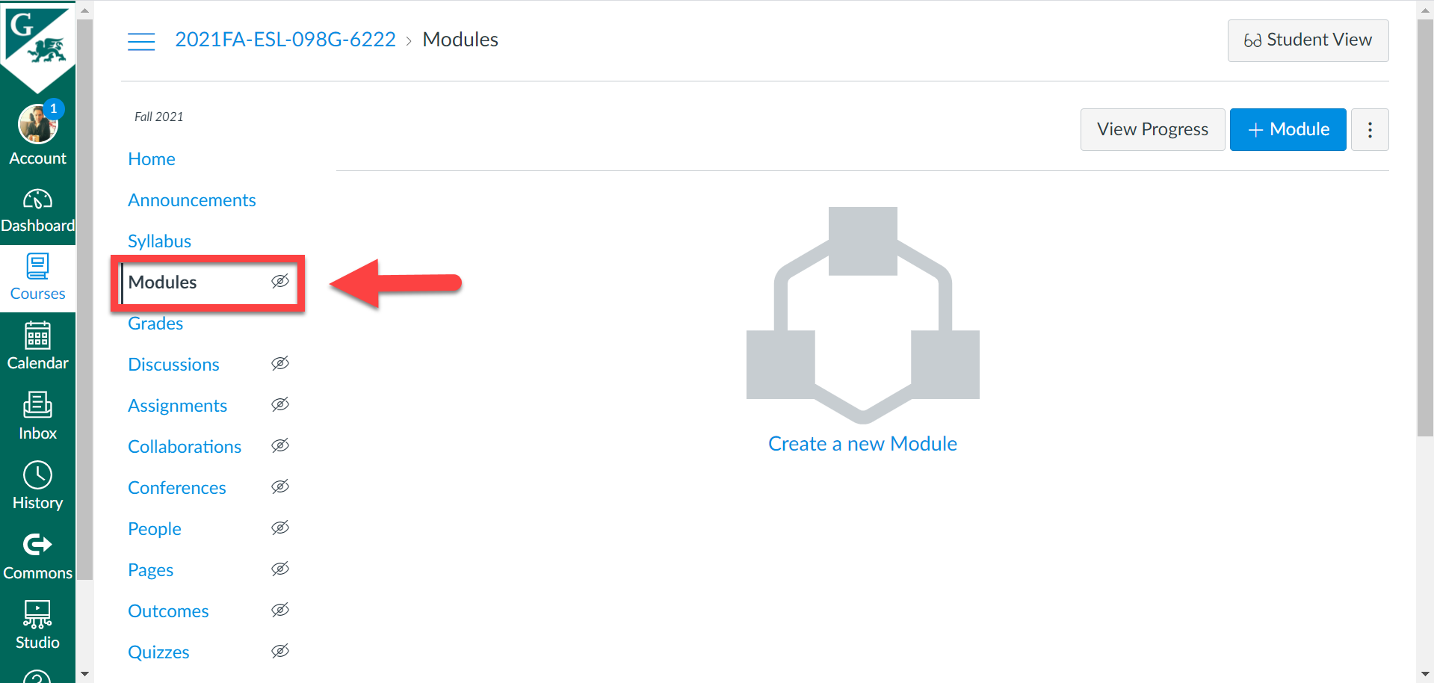

1. Next, click on the **+ Module** button on the right.

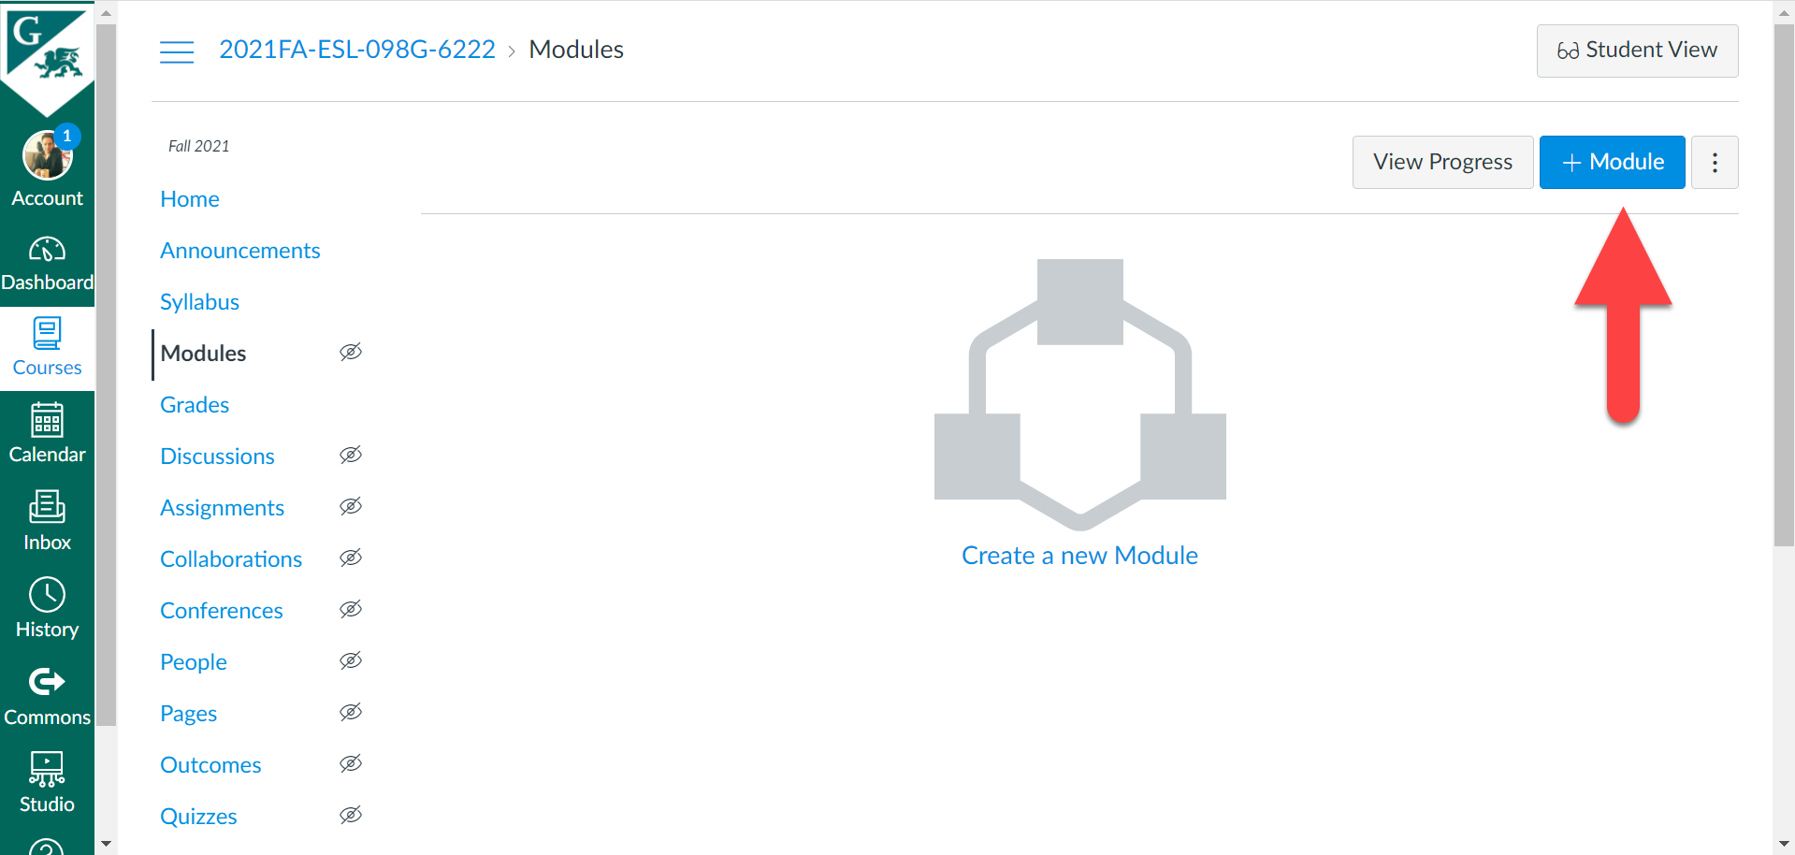

You can also click on the center image with the text, **Create a new Module.** Hovering over this will highlight this blue.

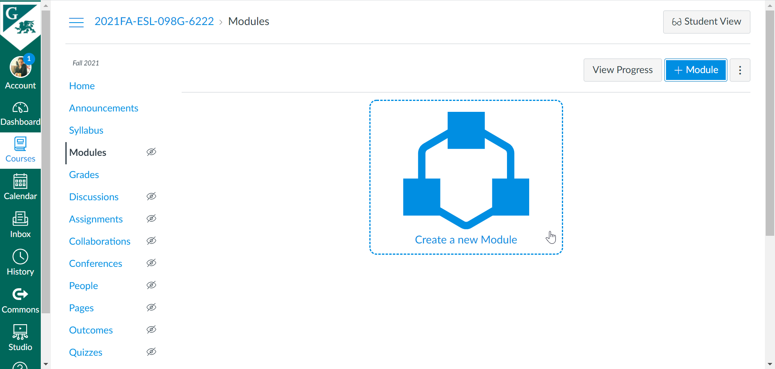

Give your module a name. If you want to have your module locked until a particular date and time, check the **Lock until** box and select a date and time, then click **Done.**

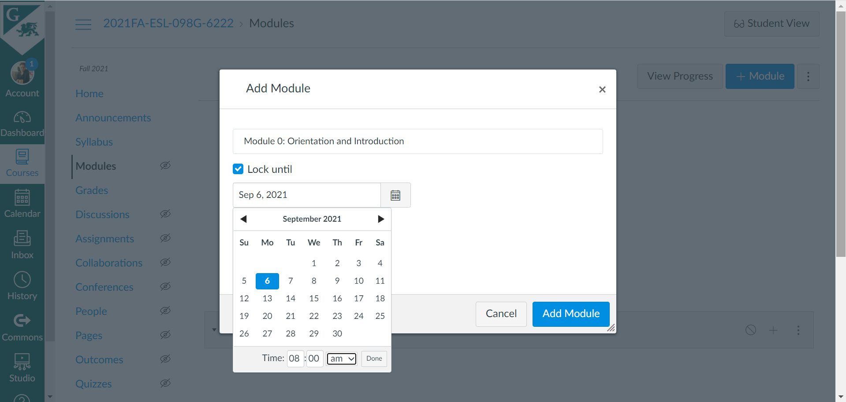

For example, if you choose September 6, 2021, 08:00 am, this means that this module will not be available to students until September 6, 2021, 08:00 am (Note that if you add a future date and time, you will not be able to view your module in **Student View,** since the date and time will have not occurred). When you have finished, click the **Add Module** button.

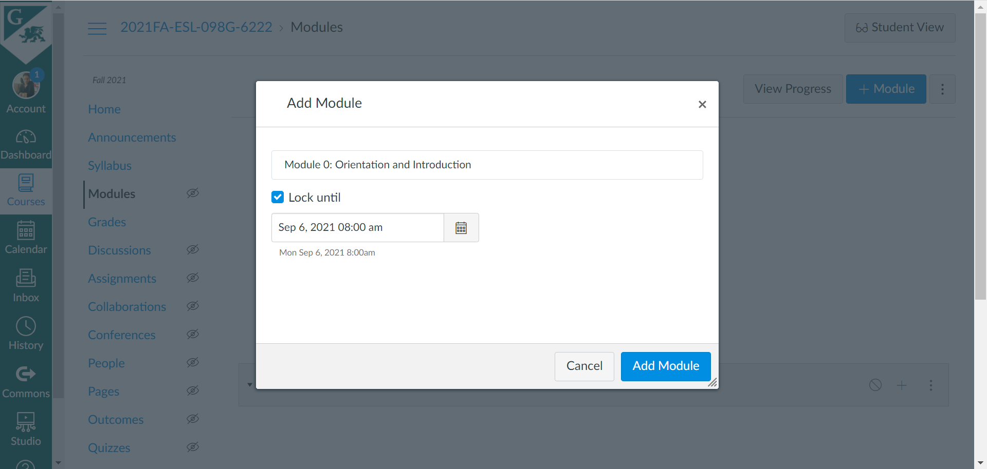

Our module has now been created and added. You can see that this module will unlock on September 6, at 8 am. Notice too the circular icon on the right. This means that the module is unpublished. Keep in mind that if something is unpublished, students will not be able to see it. In order for your content to be available to your students, you will need to publish it.

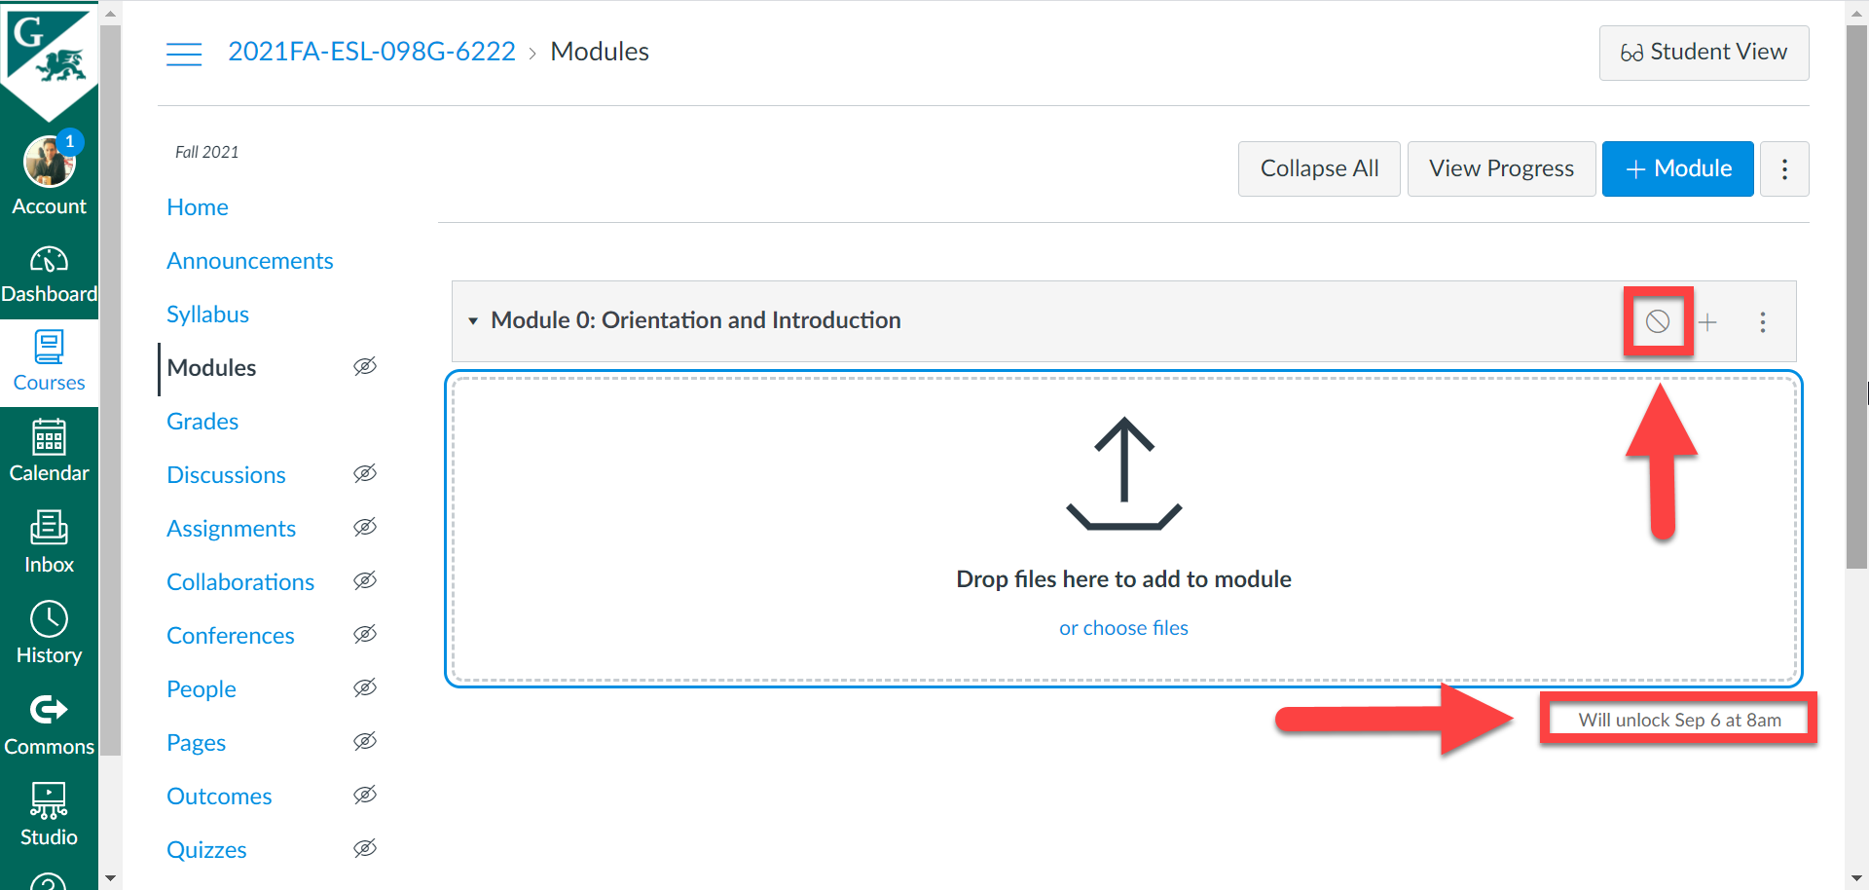

When you are ready to publish your module, simply click on the icon.

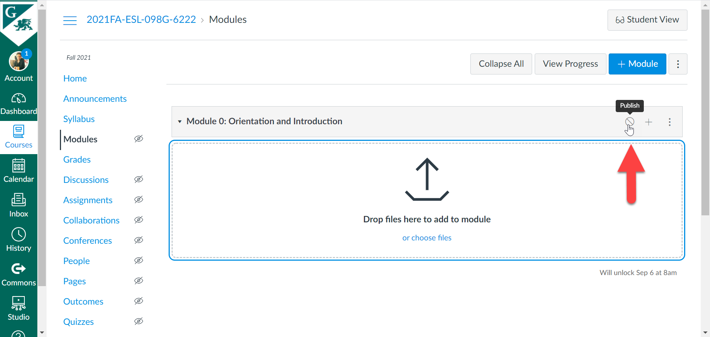

The checkmark icon means it is published.



# **Creating Pages**

**Creating a Page**

1. Now that we have created a module, let’s create pages for our module. To create a page inside your module, click on the plus sign for the module that you want to create the page for.

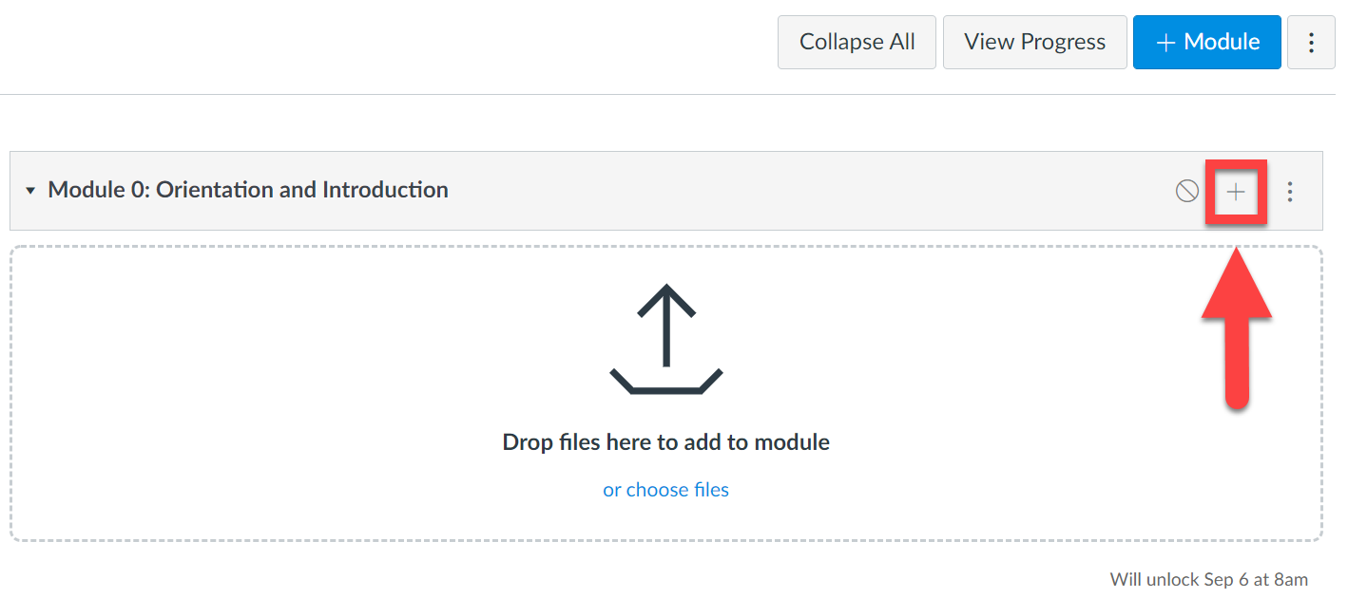

A window will open. We have different choices as to what we can add to our Module (e.g., Assignment, Quiz, File, Page, etc.). In this case, since we’re going to create a welcome page, select **Page.**

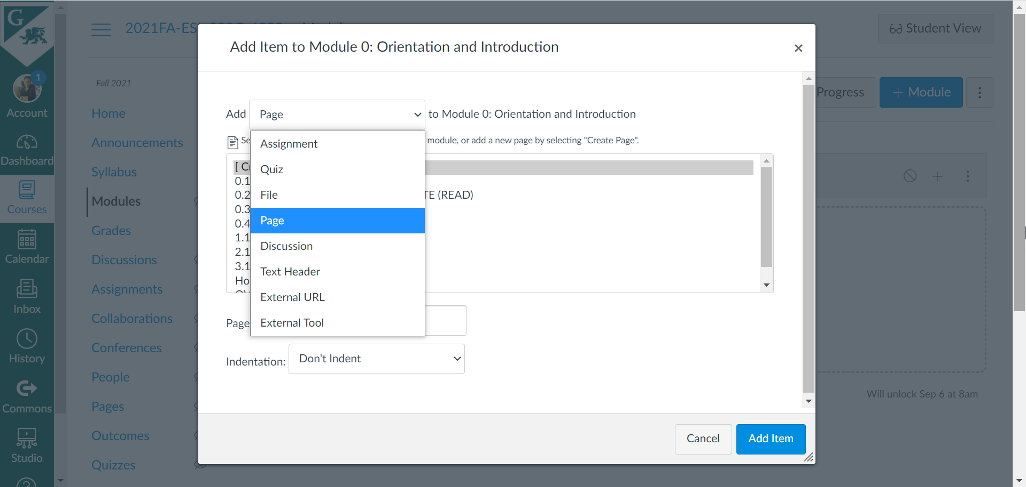

Select **Create Page,** then type in your page’s name down below. It’s a good idea your pages based on the numbering of your modules (i.e., Module 0: 0.1, 0.2, 0.3, etc.; Module 1: 1.1, 1.2, 1.3, etc.). It may also be a good idea to indicate the type of page this is so that your students know (e.g., READ, GRADED DISCUSSION, GRADED ASSIGNMENT, GRADED QUIZ, etc.). When you are finished, click **Add Item.**

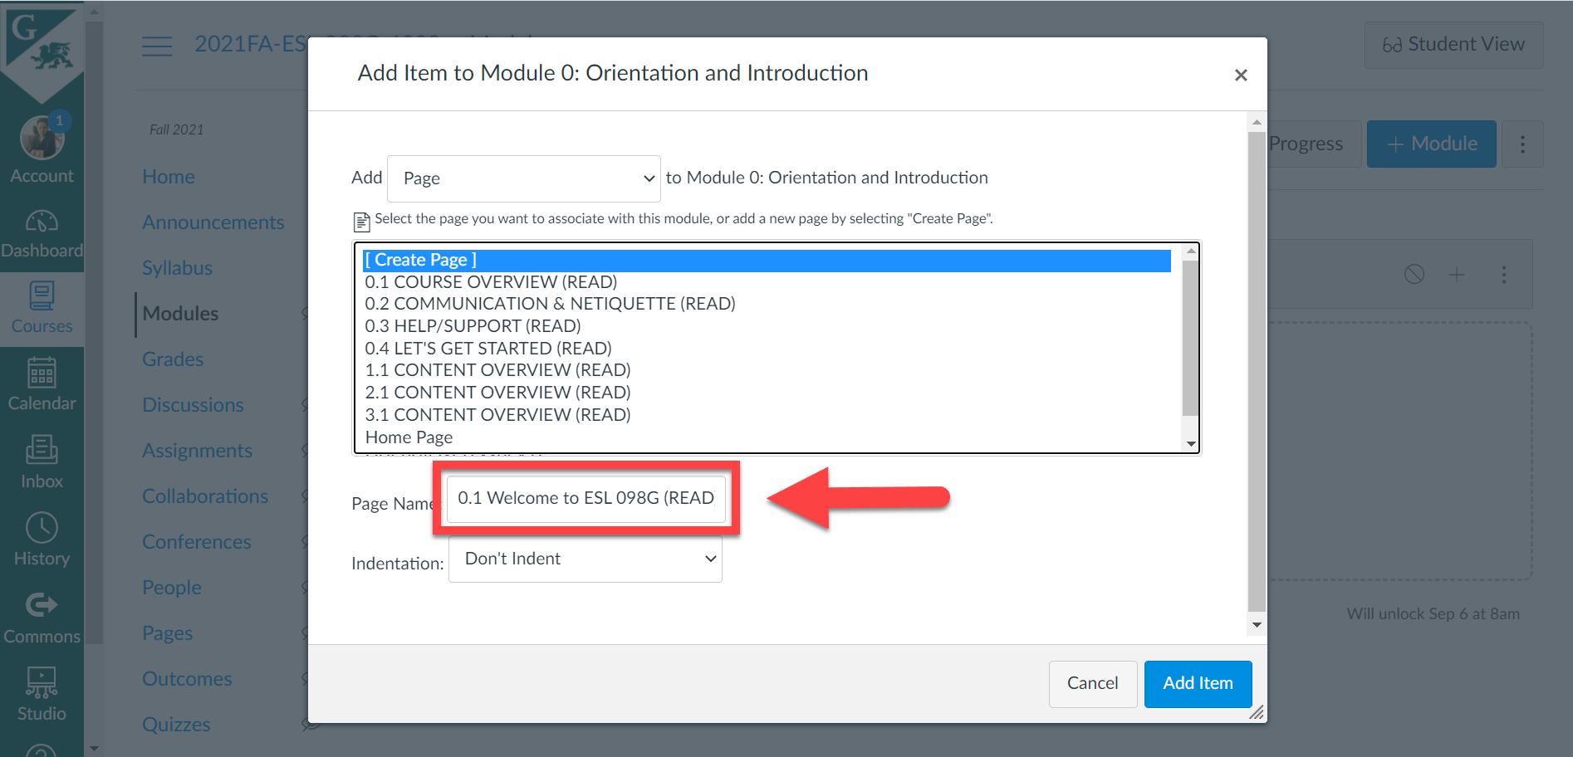

And there’s our page. We are now ready to add content to this page.

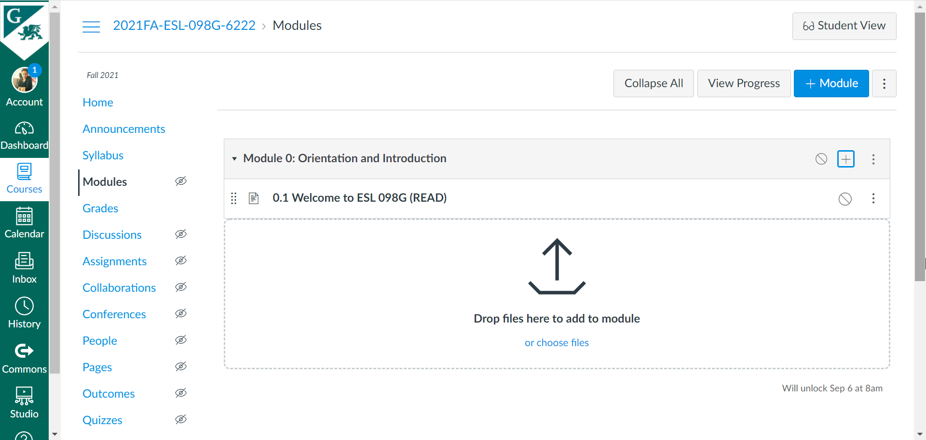

1. To do this, click on the page’s title: **0.1 Welcome to ESL 098G (READ).** This takes us to our empty page, where we are ready to add our content. Click the **Edit** button.

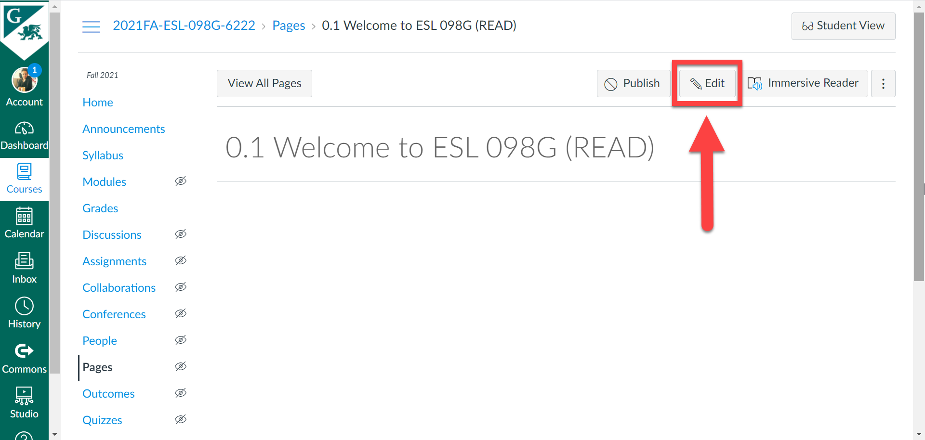

1. When the editor opens, we can now add our content. When you have finished adding your content, click **Save** down below. Note that clicking **Save** will simply save it, but it will still be unpublished. If you are also ready to publish this page, click on **Save & Publish.**

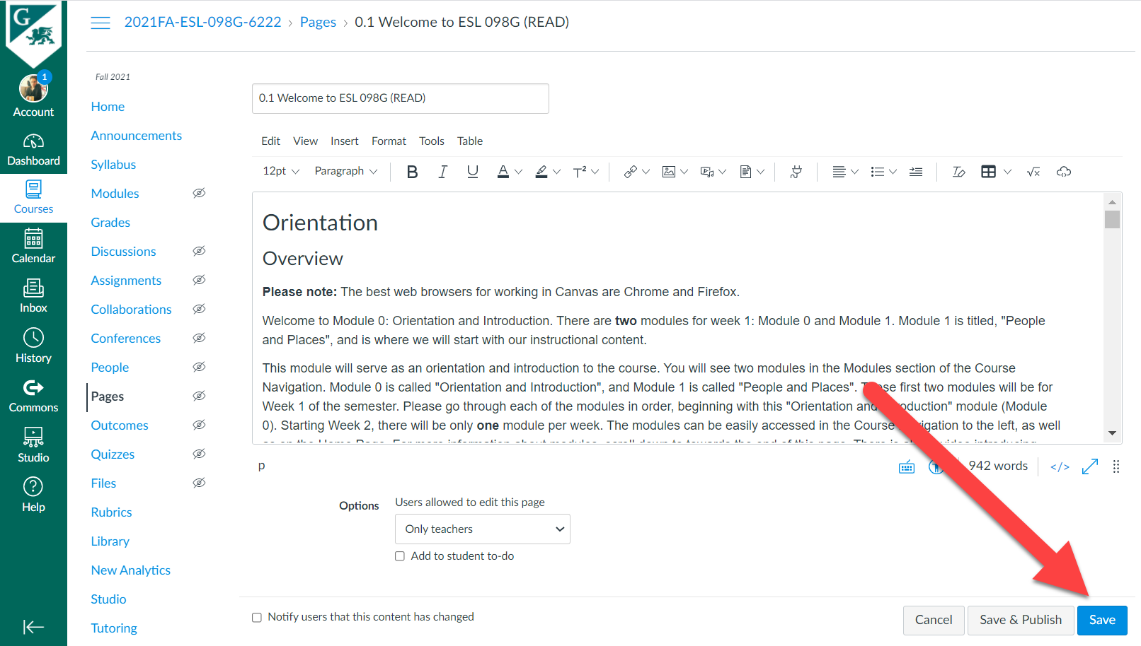

Our page now has our content and is no longer empty.

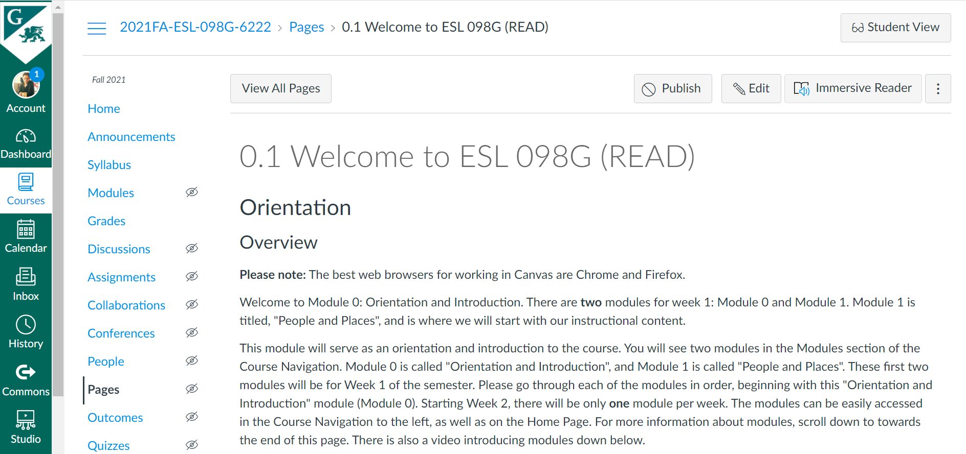

Now, when we click on the page in our Module, we should see our content. Note the icon to the left of the page’s title. The icons shown here are different depending on if this is a Page, Discussion Topic, Assignment, or Quiz. The icon here indicates that 0.1 is a Page.

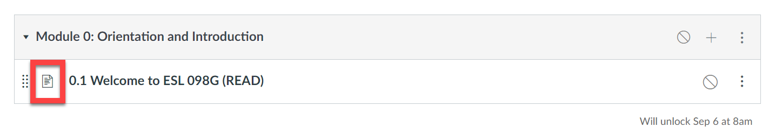

To create more pages with similar content (i.e., READ page), repeat the steps above.

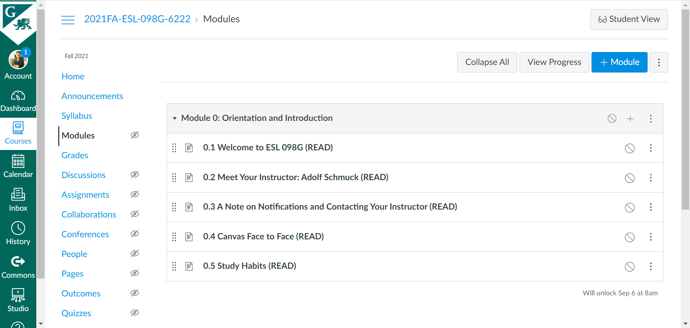

**Adding Page Requirements**

At this point, we now have some pages with content for our students to read. We have the pages of adding requirements for each page. For example, you may want to require a page to be marked as “Done” after completion, or simply have them “View” it without any requirements.

1. To add a requirement, click on the three dots on the Module tab, then select **Edit.**

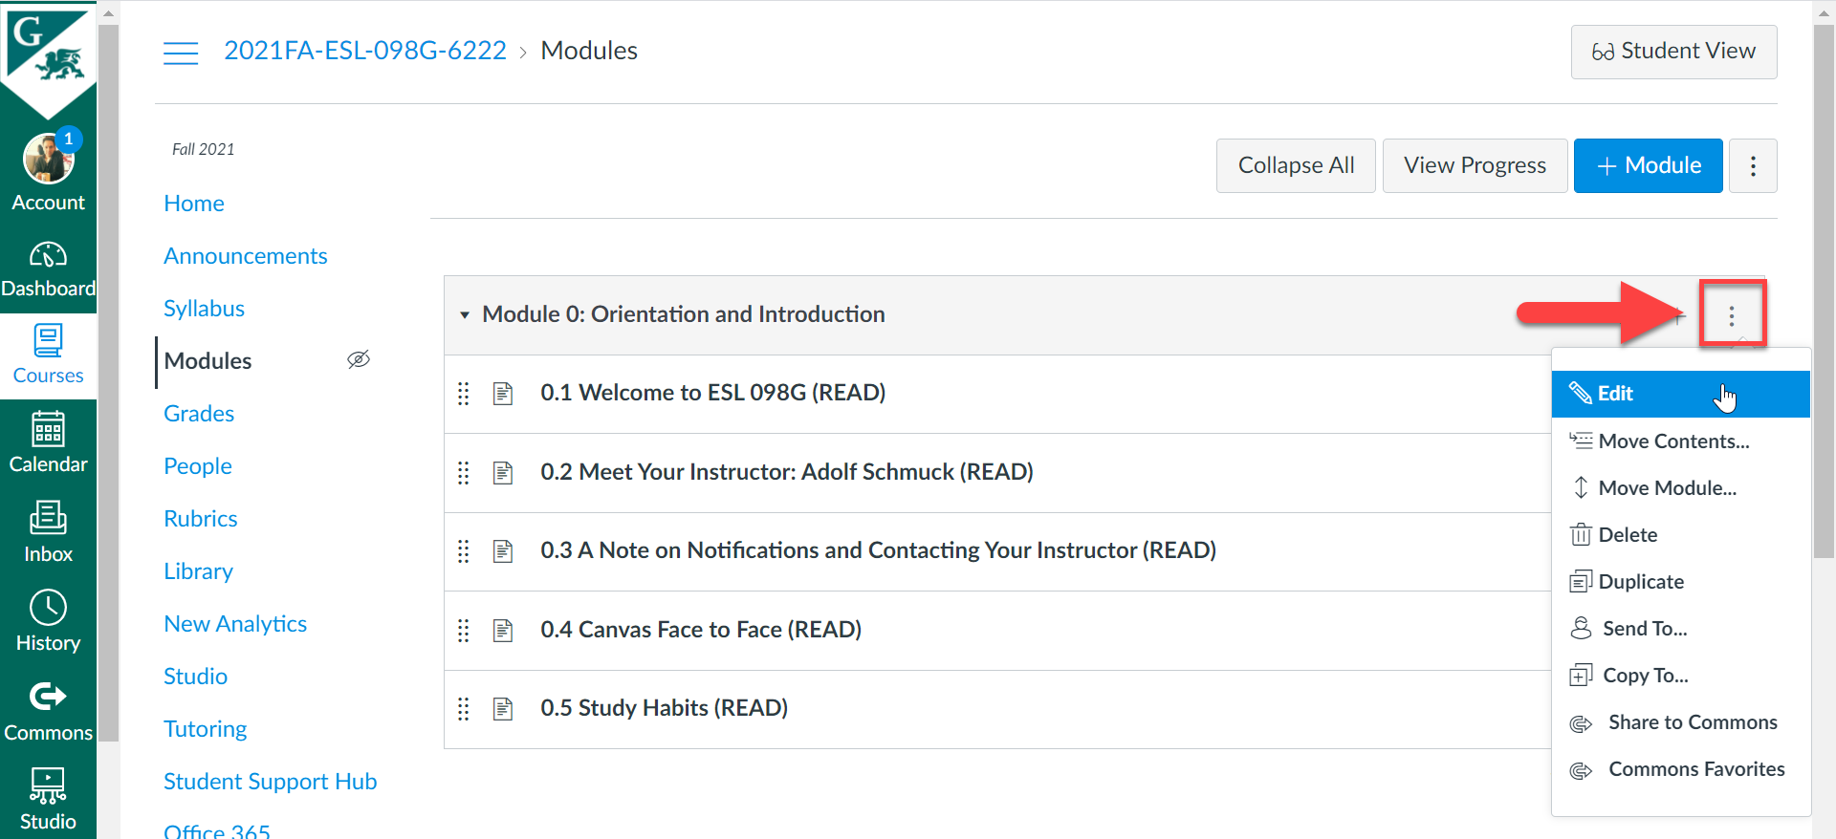

When the window pops up, click on **+ Add Requirement.**

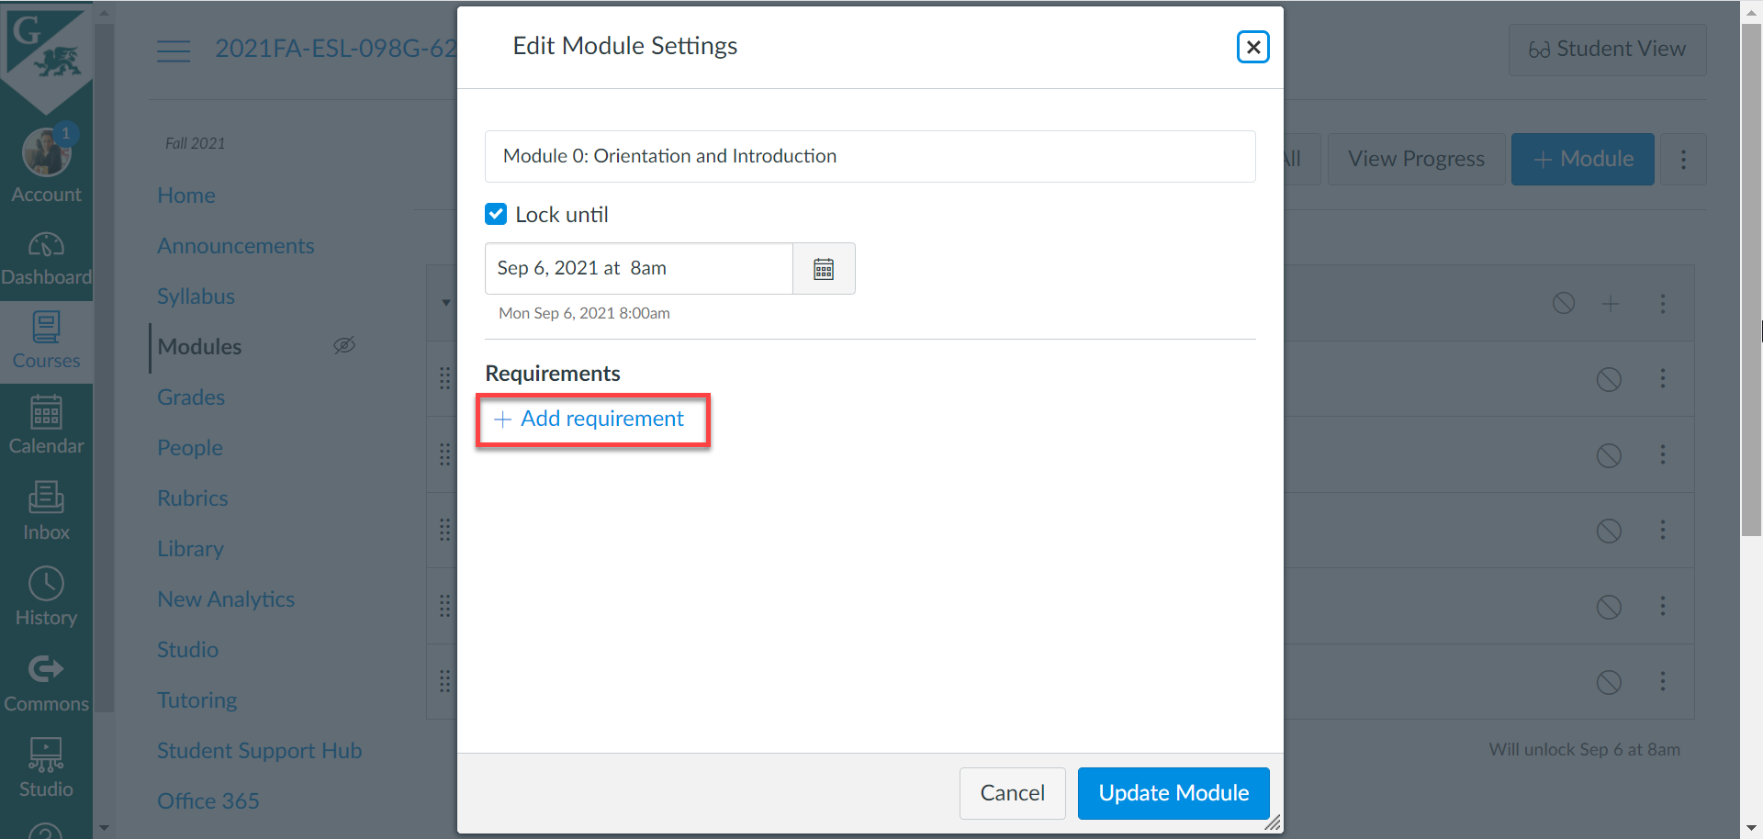

Here, you have some choices: Students must complete all of these requirements, Students must move through requirements in sequential order, Students must complete one of these requirements. Select the one that fits your needs.

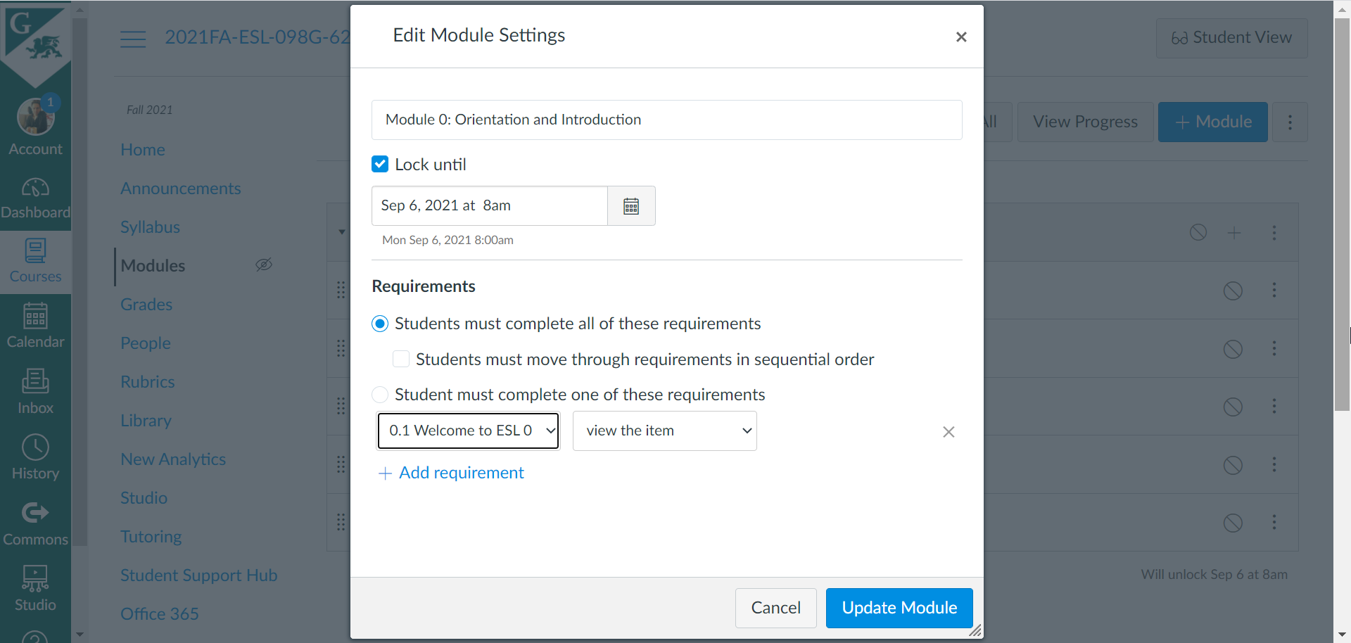

Select the page you want to add a requirement to from the dropdown menu on the left. For this example, we will choose page 0.1. Then select the requirement from the dropdown on the right. We want **mark as done.** So, select that, then click **Update Module.**

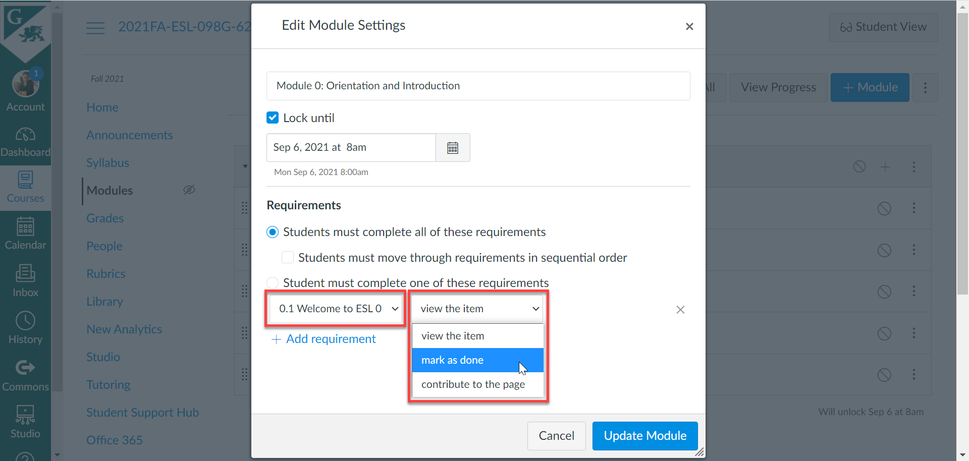

As you can see, it is now designated as “Mark done”. This means that the students need to mark this page as done before continuing to the next page.

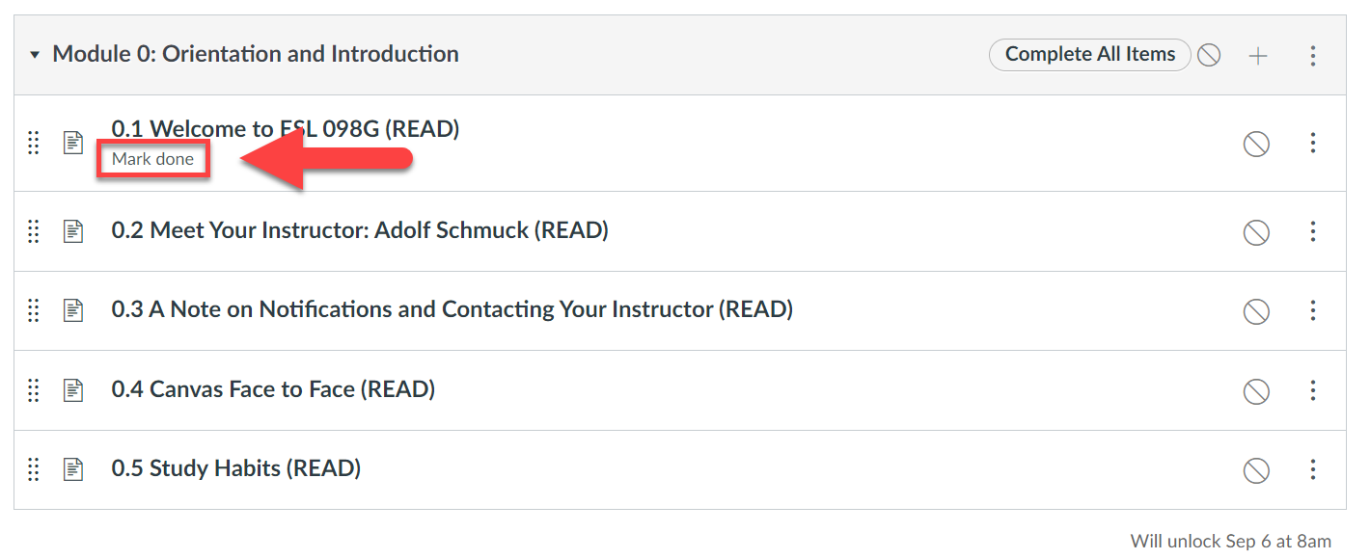

1. To mark a page as “View”, start by clicking on the three dots as before. You’ll notice that we have our **mark as done** requirement for the first page. Now, since we want to add another requirement for our next page, click in **+ Add requirement.**

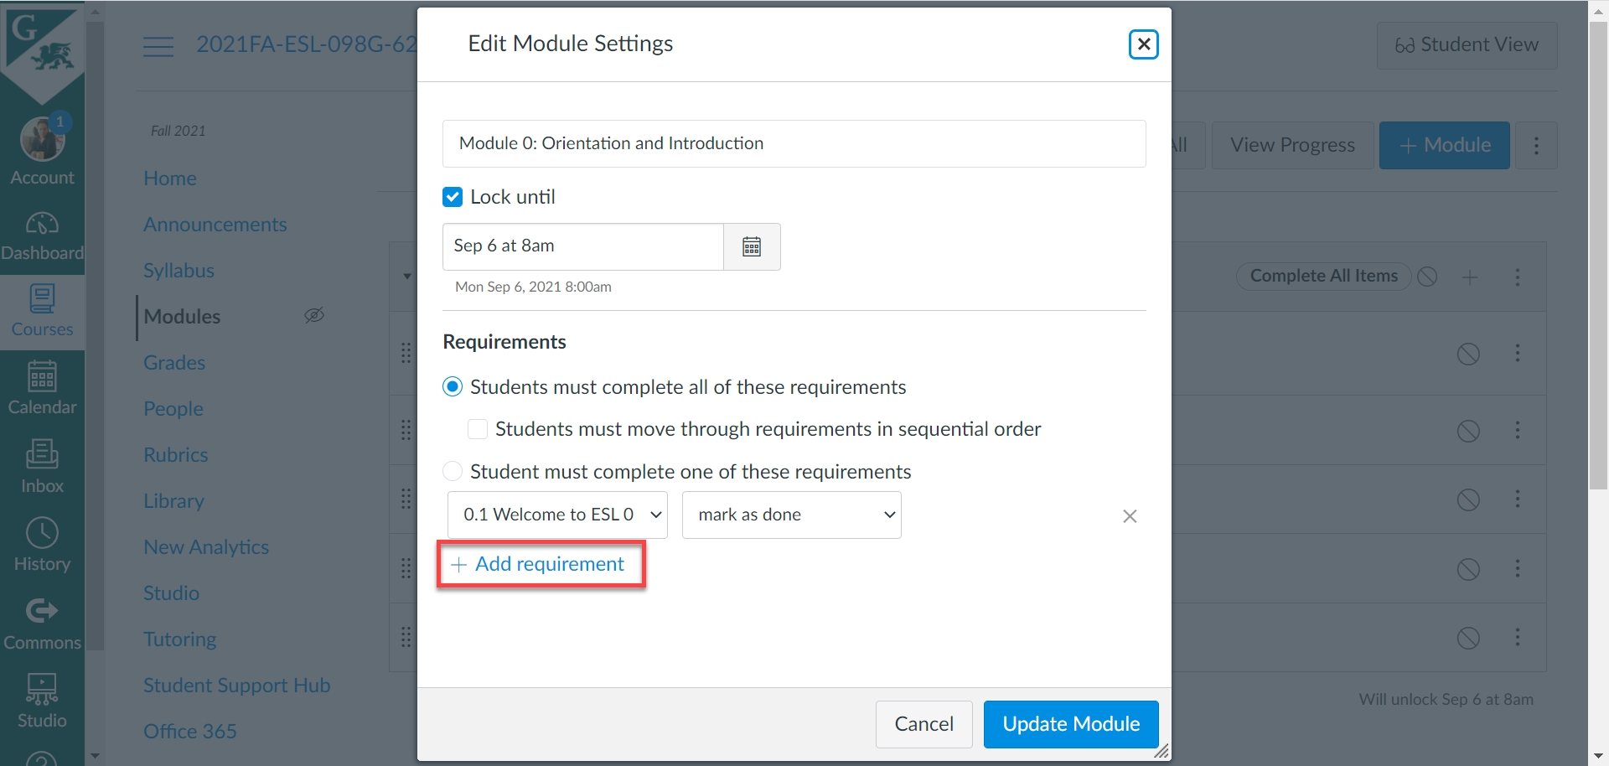

Next, choose the page (e.g., 0.2) and select **view the item.** Then, click **Update Module.**

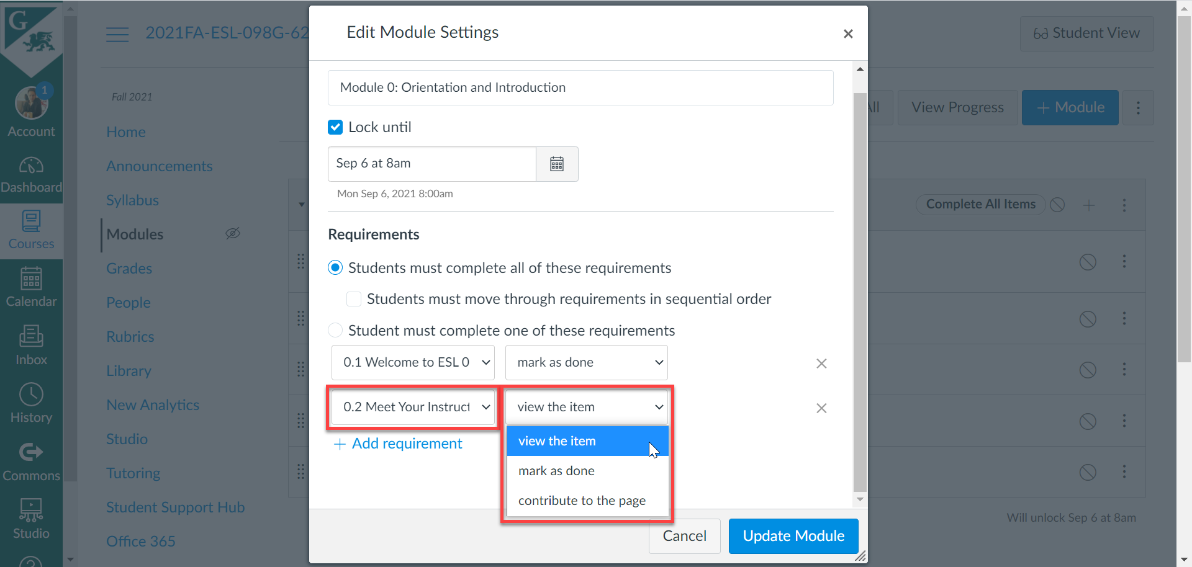

And now our second page is designated as “View”.

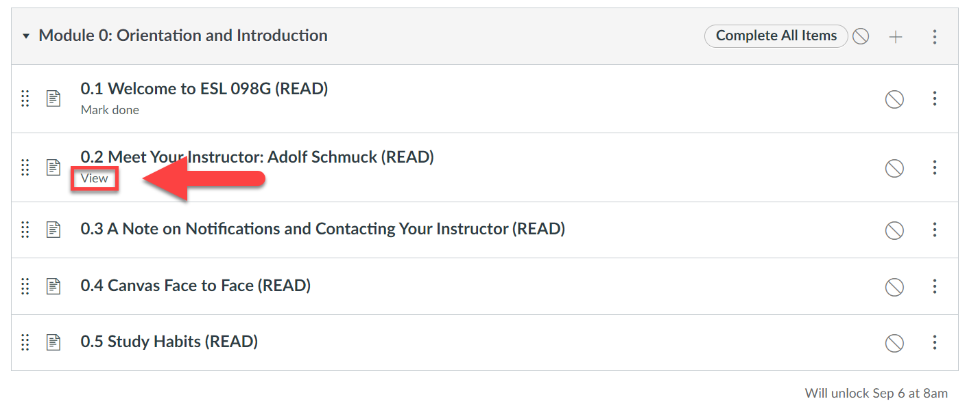

And we can go ahead and add requirements to the rest of our pages.

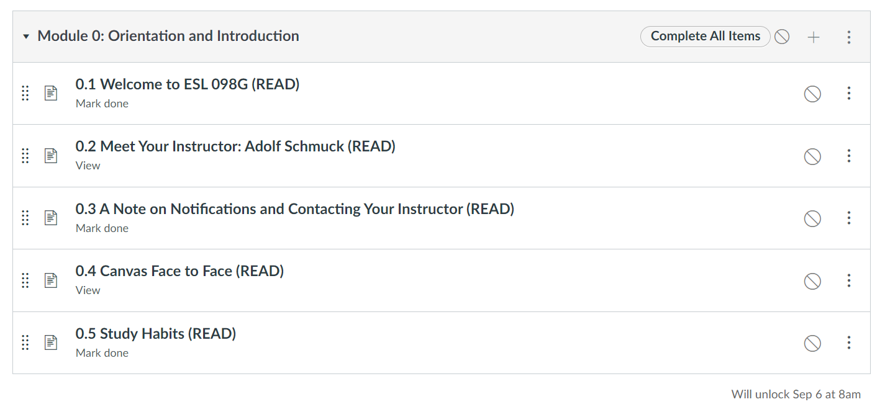

1. To see what this looks like for students, we can go into **Student View.** As noted above, if set a future date and time for our Module to unlock, we will not be able to view our Module in **Student View.** Because we want to see what it looks like in **Student View,** let’s go ahead and review our “Lock until” date. So, click on the three dots to edit the Module. Then, uncheck the “Lock until” box to remove the date and time. Then, click **Update Module.**

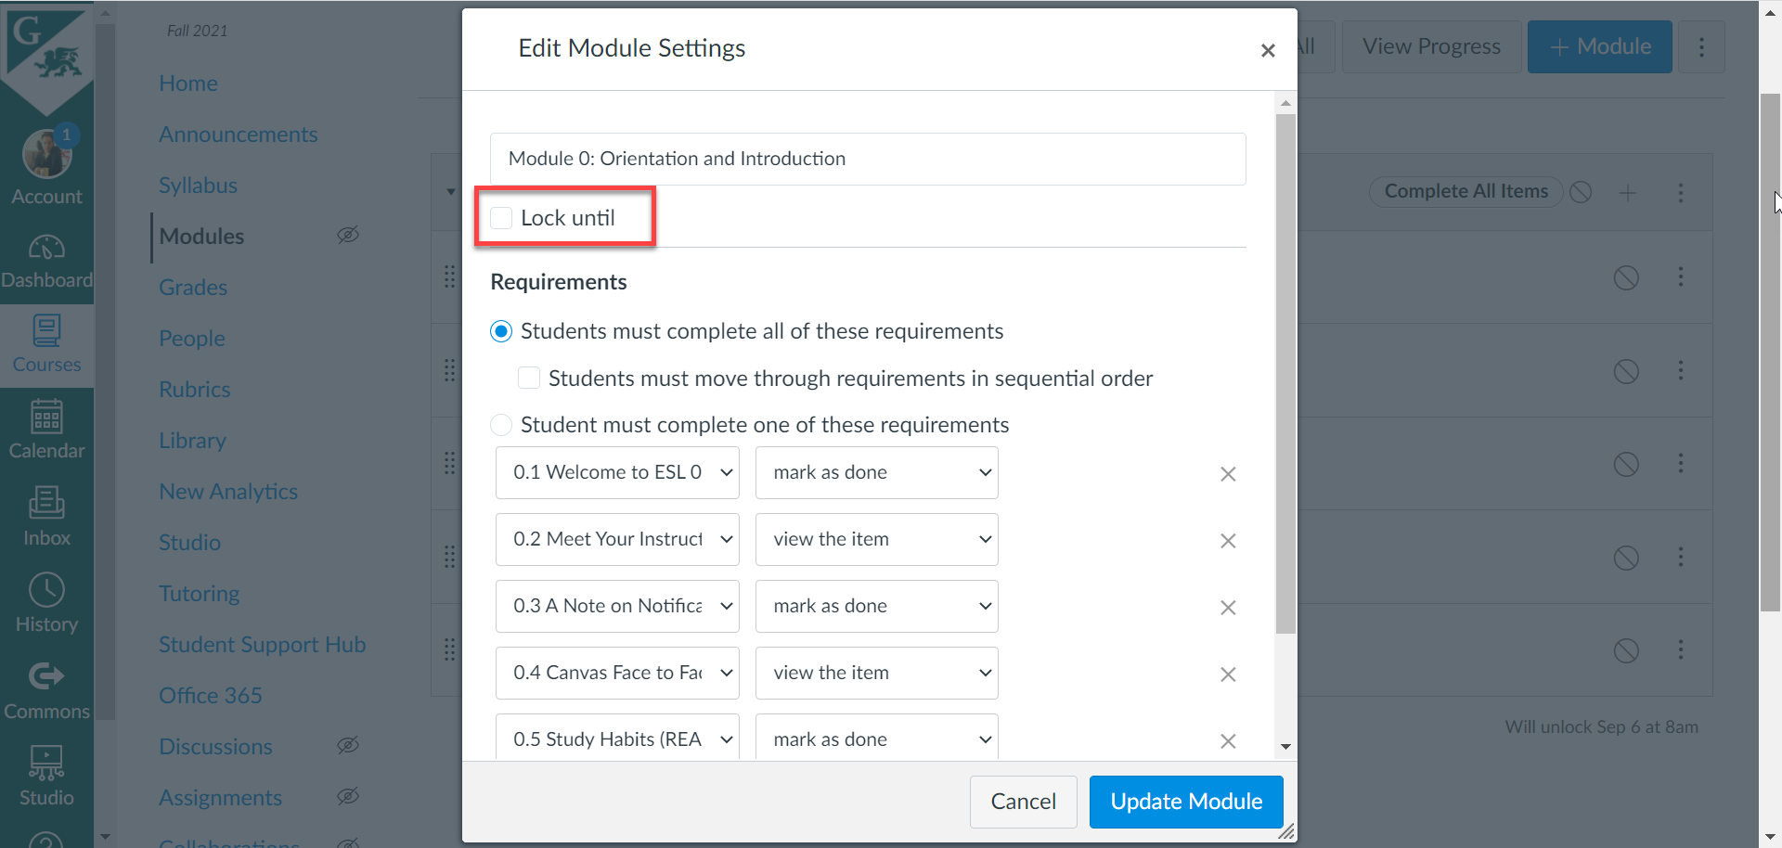

Now, we no longer have a date and time. This means that this Module will be available to students at any time.

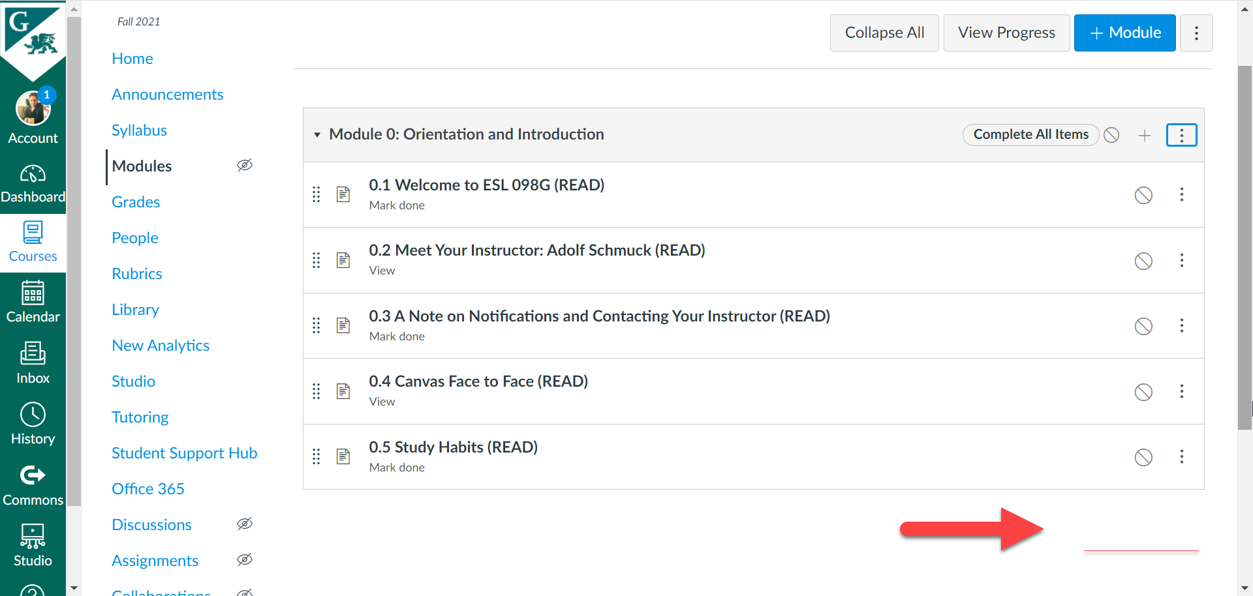

1. There’s one more thing that we need to do before we can view our pages in the **Student View.** You’ll notice the icon on the left, next to **Modules.** If you hover over the icon, it says, “No content. Not visible to students”. If we try to enter **Student View** now, we will not be able to see our Modules, because it is not visible.

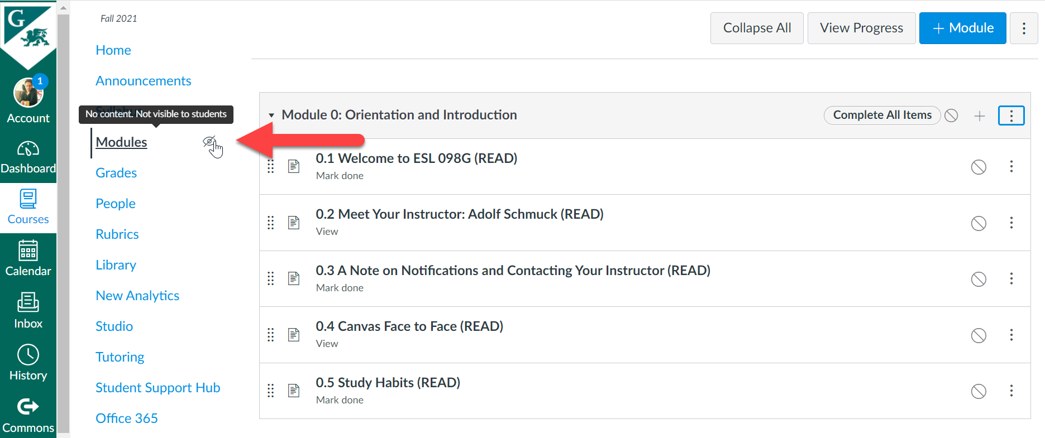

1. So, what we need to do is to publish our Module. To do this, click on the icon to the right on the Module title bar. You will now see a checkmark. Doing this will publish all of the other pages at the same time. Note that publishing a module is not the same as publishing your course. Remember that if we look in the Dashboard, our class will still be unpublished. You will still need to publish the entire course in order for the students to see the course, with the contents.

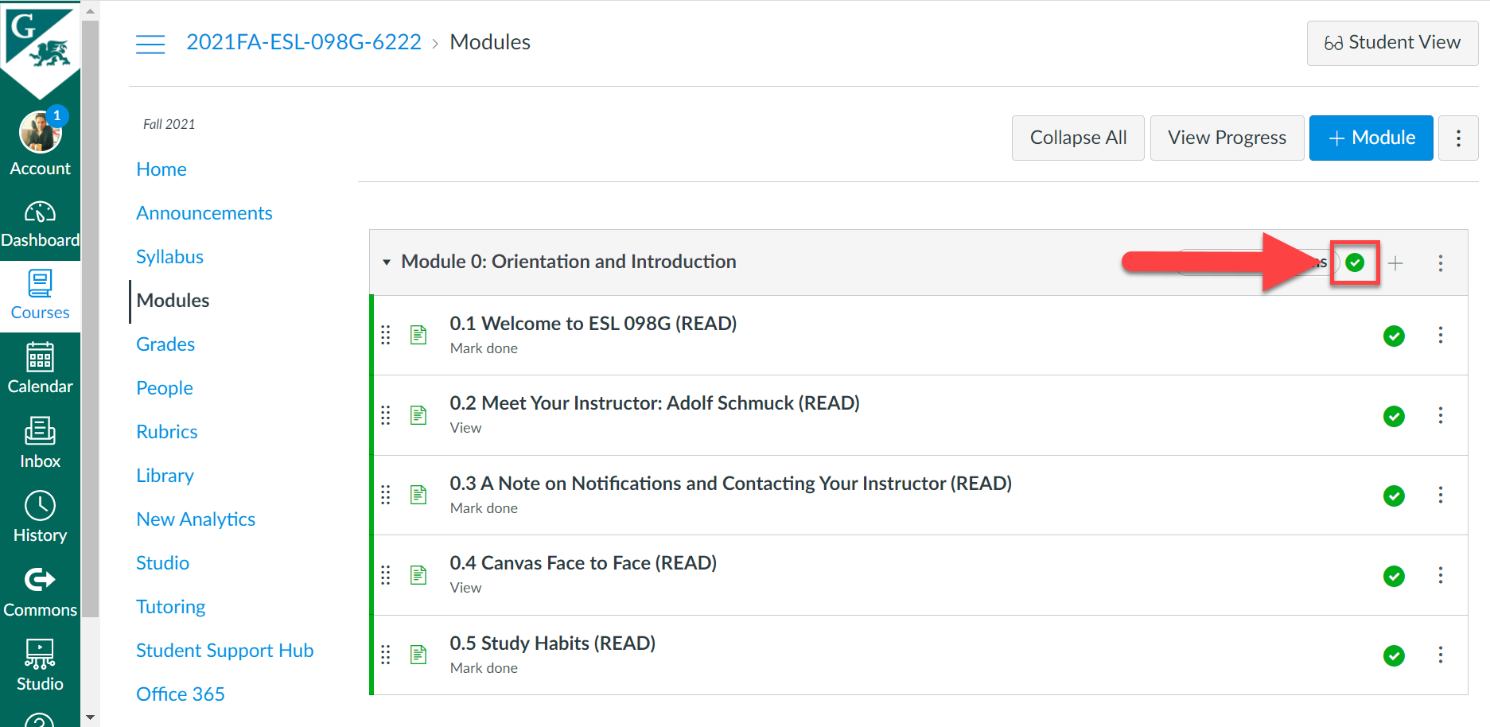

Note too that the icon that was there before is now gone, which is what we want. This means that the content will now be visible to students. We are now ready to check in the **Student View.**

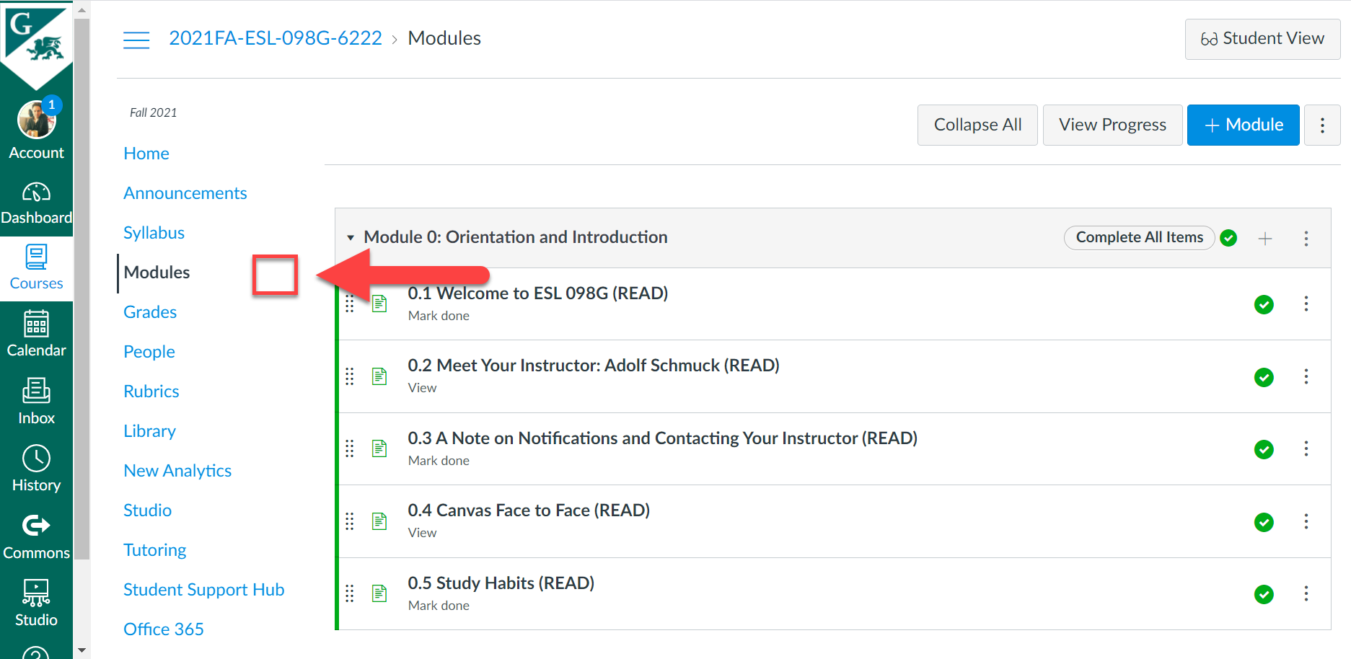

1. To go into **Student View,** first, click on **Home,** then on the left. You will then see the **Student View** button on the right. Click on that.

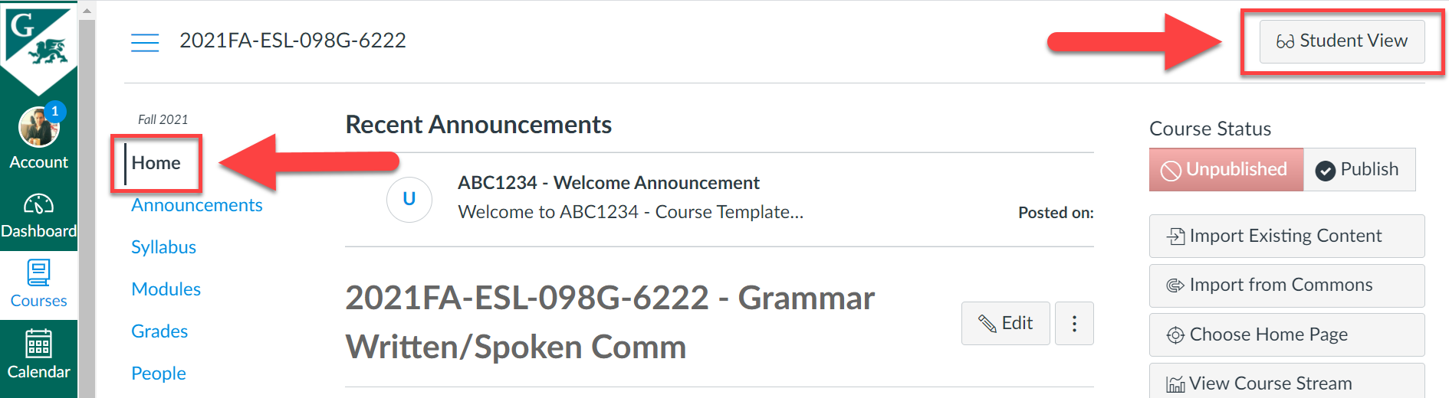

We can see that we are now in **Student View.** And if we click on **Modules,** we can now see our Module.

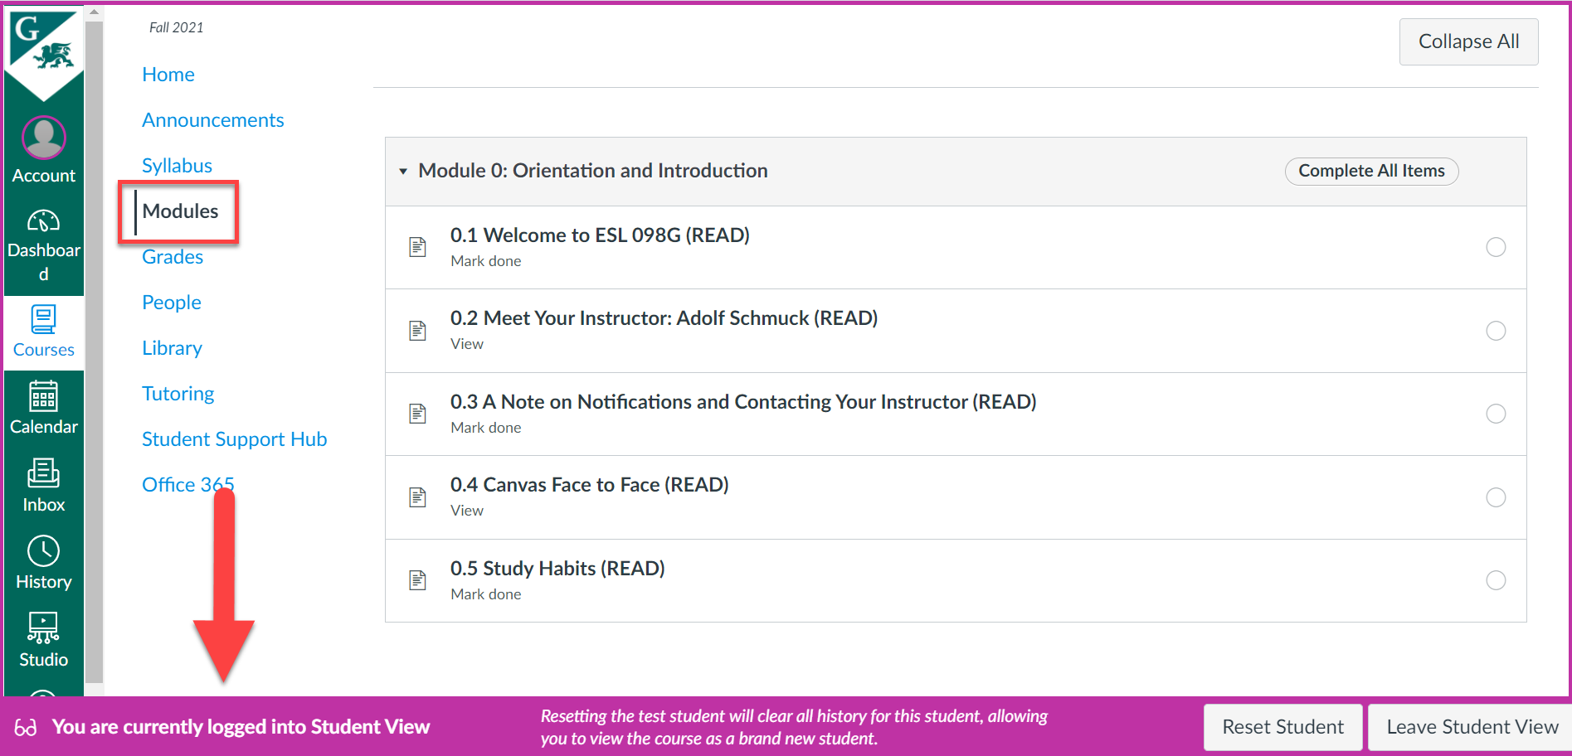

Let’s go into the first page of our Module, which we designated as “Mark done”: **0.1 Welcome to ESL 098G (READ).** As you can see, students are required to mark this page as done when completed.

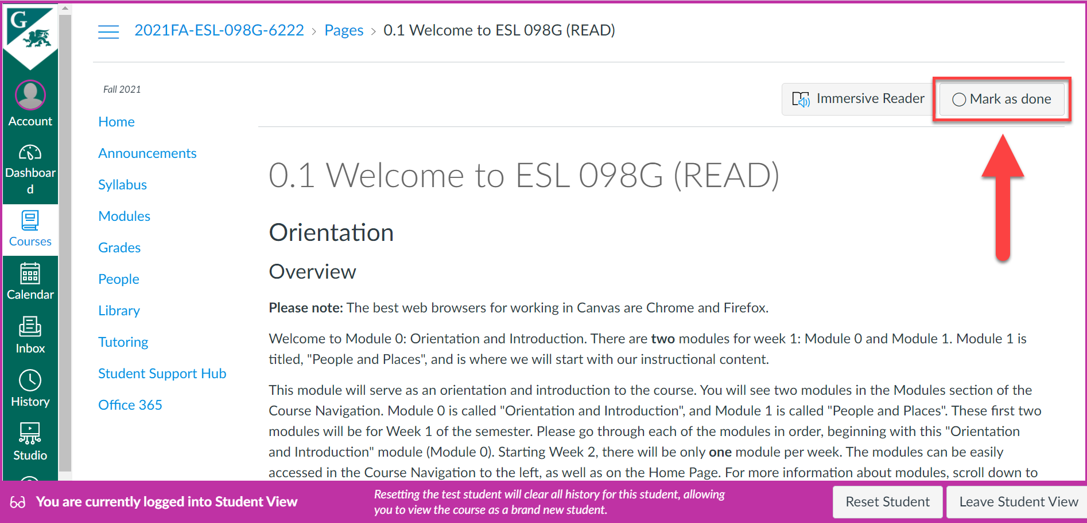

When this is clicked, it will be marked as “Done”.

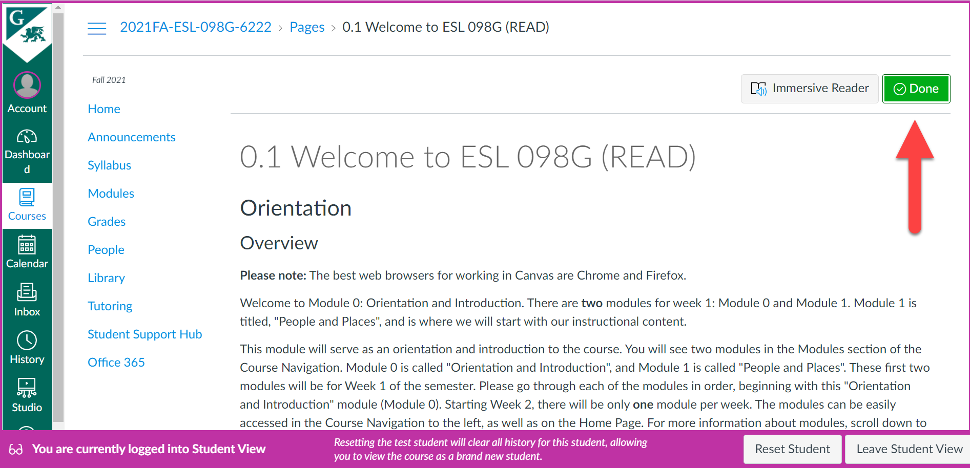

Back on the main Modules page, the checkmark let’s the students know that this page has been marked as “Done” and completed. On the left, the page is now designated as “Marked done”.

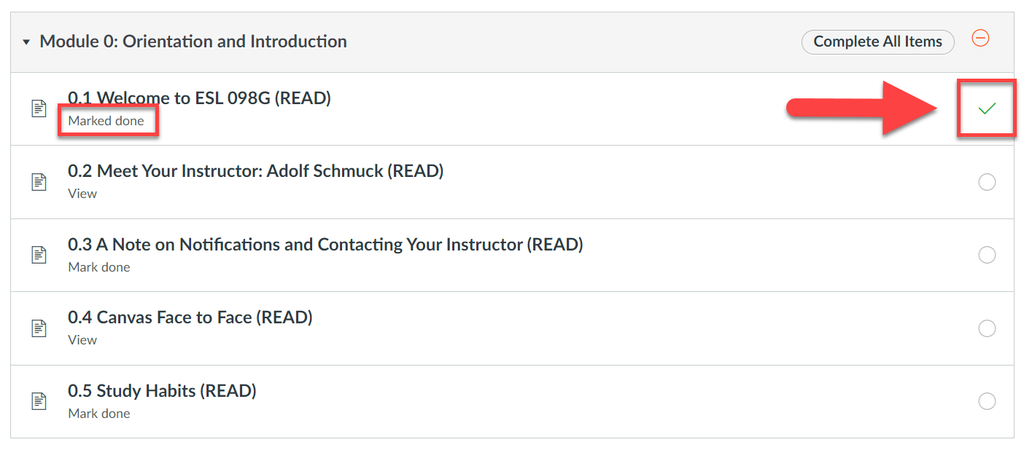

Students completing pages designated as “View” (e.g., 0.2) will get a checkmark indicating that this page has been completed. Since this page does not require students to mark it as done, students simply have to read it and continue to the next page for it to be considered completed. When completed, the designation on the left will be changed to “Viewed”. Deciding which requirement to use depends on the instructor and course requirements.

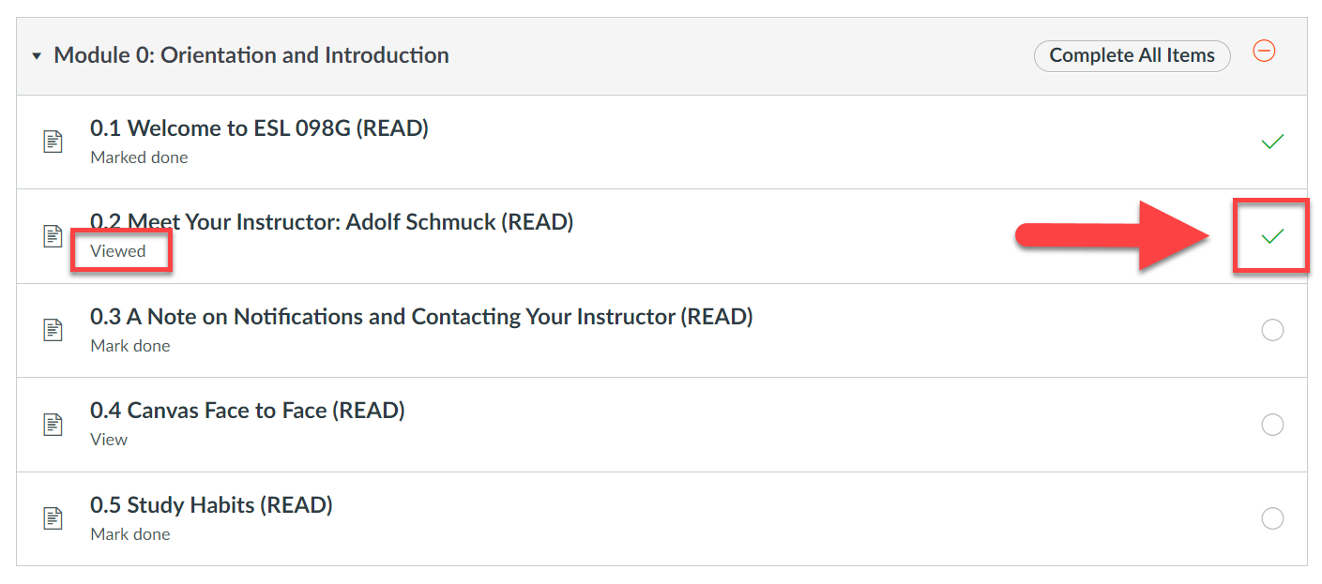

1. So, we now know what this will look like to the students. To exit **Student View,** simple click on the **Leave Student View** button on the bottom.

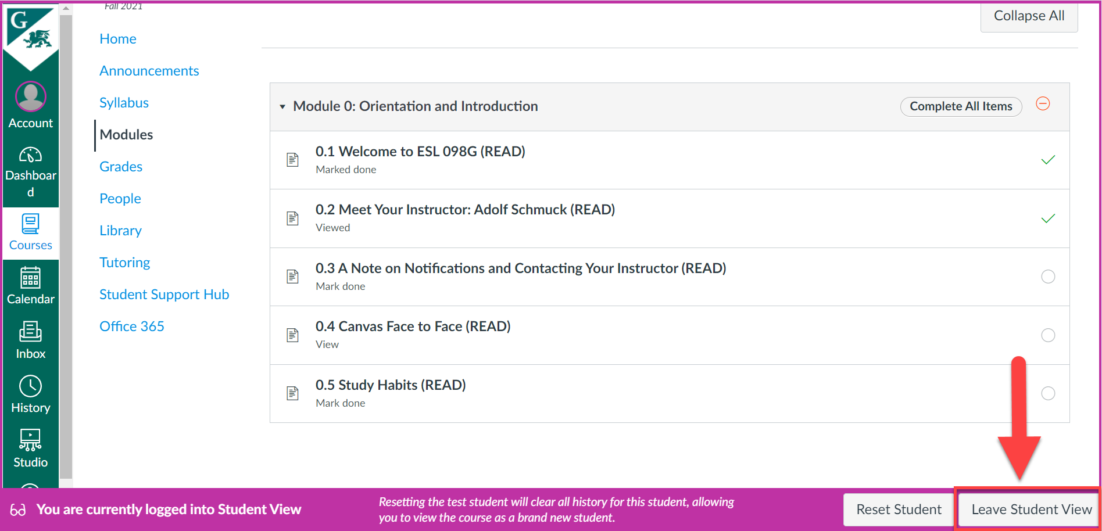

**Creating a Discussion Topic**